**SOFT336SL**

**Cross-Platform Application Development in C++**

**Noteculator**

**User Documentation**

**About Noteculator**

Noteculator is a program with a rich text editor and a calculator. It helps to edit and format text documents, save them etc. and to use the calculator when in need. Specialty of Noteculator is that the user is given a user-friendly graphical user interface with some additional features and a calculator that would be benefitable for budget planning, academic purposes, and any other user wanting to do basic mathematical operations while documentation.

The program is a cross platform software implemented using QT in C++. Further technical details are included in the technical documentation.

Functionalities and Features:

The program allows user to:

* Create new text files
* Open the created files
* Edit existing files
* Save changes
* Save file with a name
* Print
* Cut, Copy & Paste text
* Redo & Undo changes
* Use Calculator for operation-
  + Addition
  + Subtraction
  + Division
  + Multiplication
  + Change sign into plus /minus
* About the Application
* Formatting
  + Change font style and size of the text in the doc
  + Change font color for in selected text
  + Highlight text – Highlight and By choosing white color, remove the colors
  + Bold, Italic and Underline
  + Bulleting –
    - Numeric – Arabic, Roman
    - Alphabetic – Uppercase, Lowercase
    - Bullets – Dots, Disc, Square
  + Align
    - Left
    - Right
    - Center
    - Justify
  + Zoom In & Zoom Out

Improvements to be done:

Adding tables and images, more operations on the calculator, Getting total into the text editor

**User Manual**

To run the application please download the zip file and extract in your QT workspace. Select and open the QT project file (.pro) from open project in QT Creator. I have used QT 5.15.1 version for the implementation. As you open the project you might get a configuration message to configure the project. Select your toolkit from there and you can run it when the project opens.

**Supported Platforms**

Qt 5.15.1 was used to implement the software

**Ubuntu**

To run on ubuntu the program was configured for the toolkit for GCC compiler. Additional **libglu1-mesa-dev** and **libxcb-xinerama0** libraries installation:

* **sudo apt-get install libglu1-mesa-dev**
* **sudo apt-get install libxcb-xinerama0**

Following were the qt components installed.

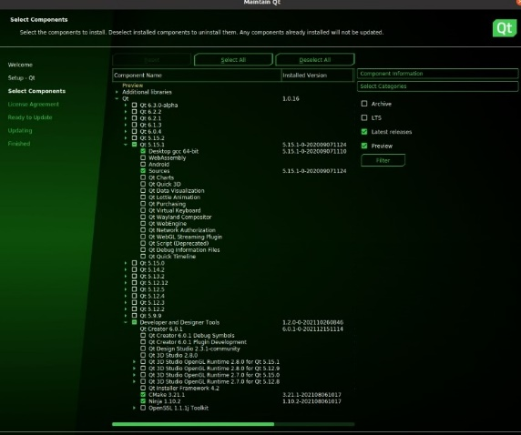

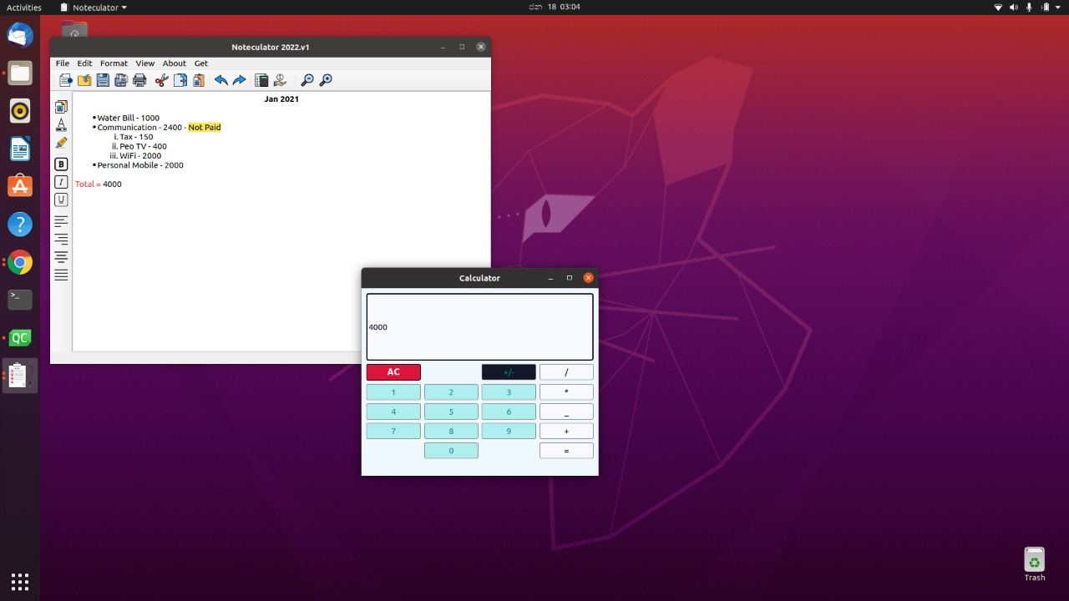

**Windows 10**

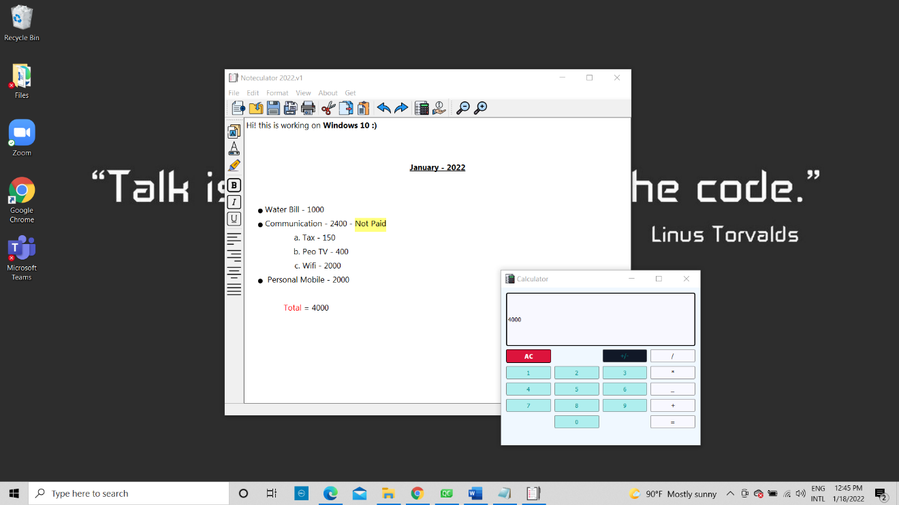

**Technical Documentation**

**Description of the GUI Design**

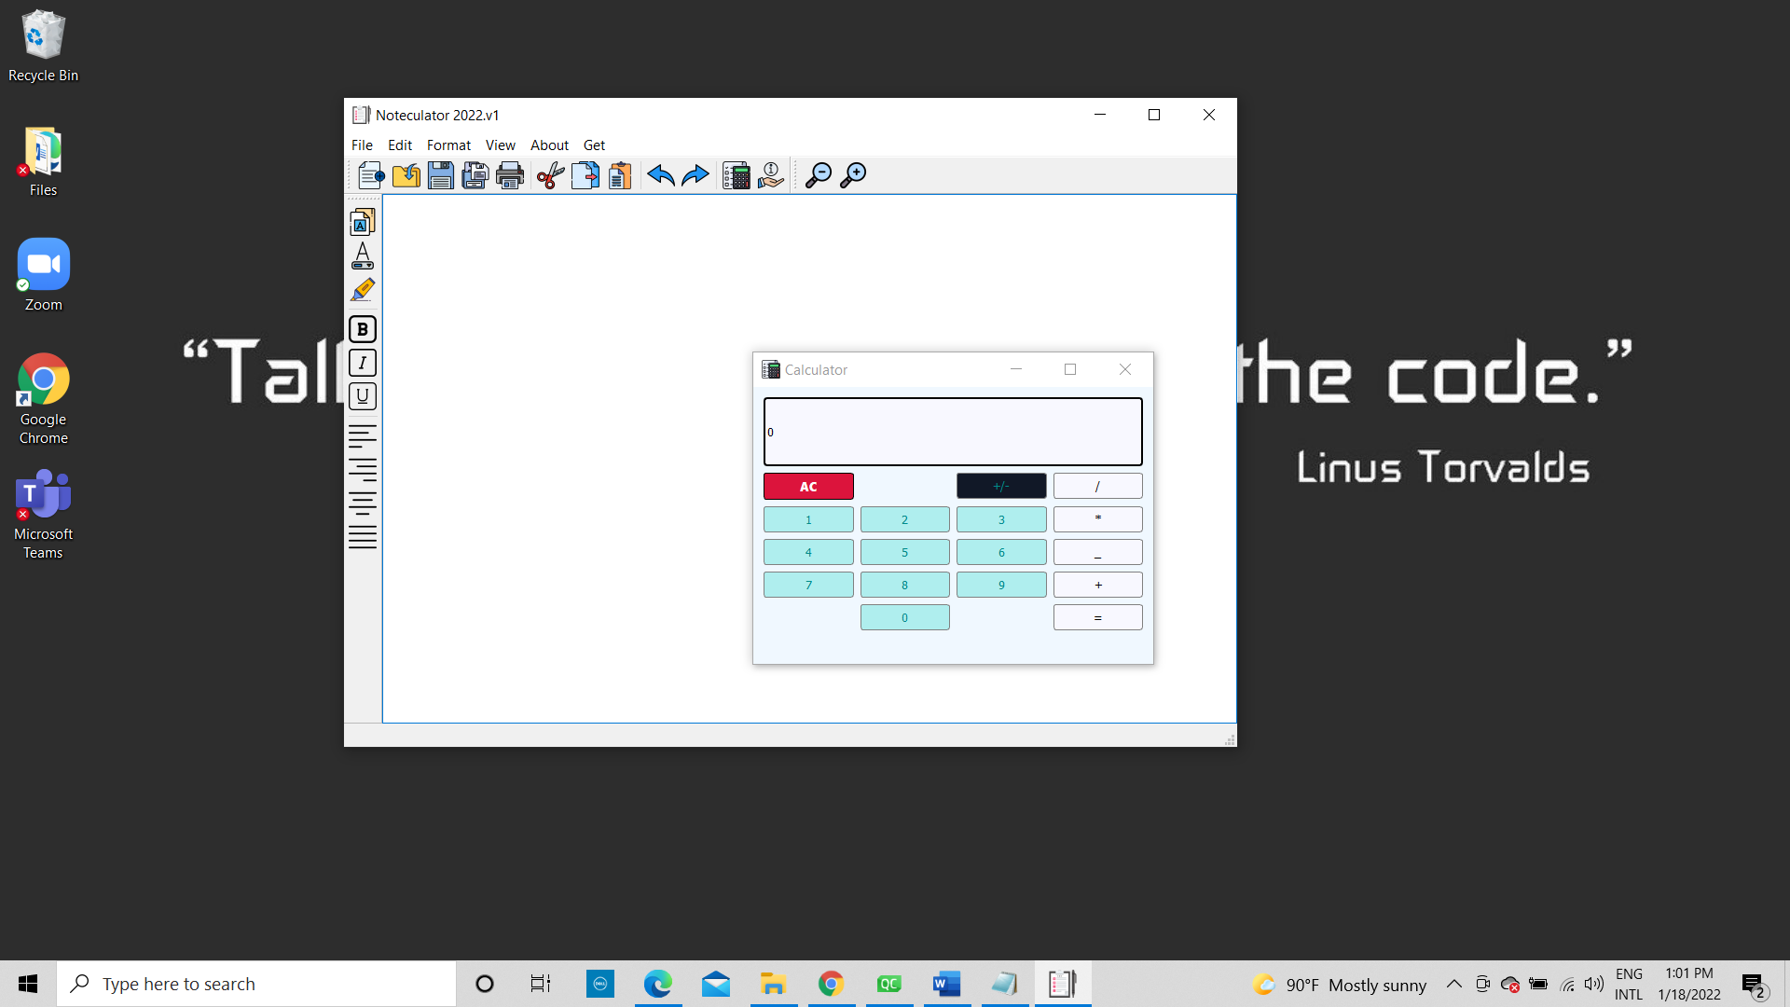Text Editor contains a text edit, menu bar, tool bar and a formatting tool bar. Text Editor class inherits from the QWidget class and to designing the menus, toolbars, menu items with signal and slot connections and with a central widget, QMainWindow class was used. QTextEdit, QMenuBar, QMenu, QActions, QToolbar were used for the text editor. Using QDialog class the calculator was designed and a non modal dialog was used to make sure the user can use text editor and calculator both at once. For the calculator CSS stylesheets were used for the pushbuttons and the text edit.

Menu Bar

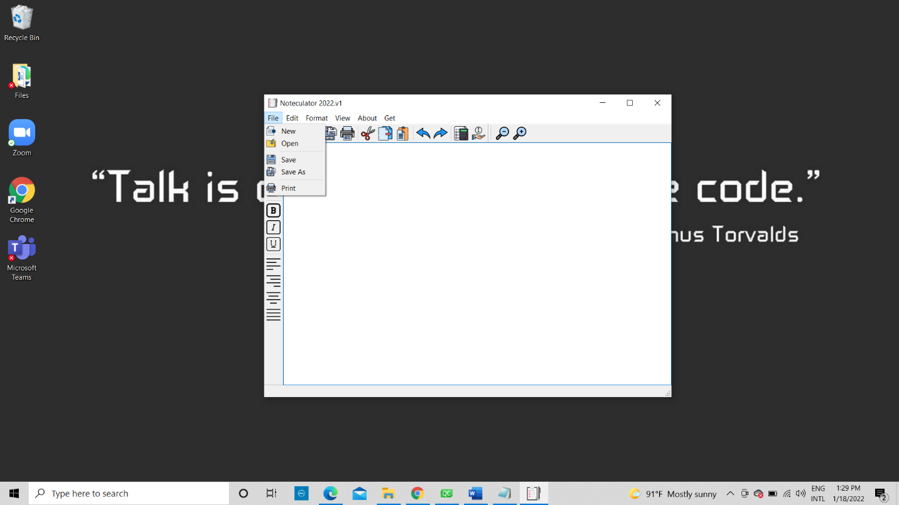

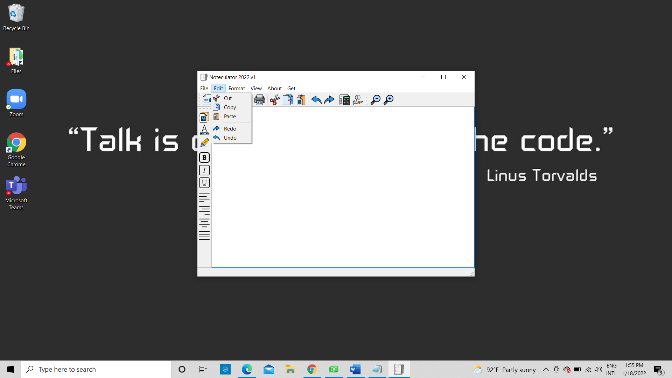

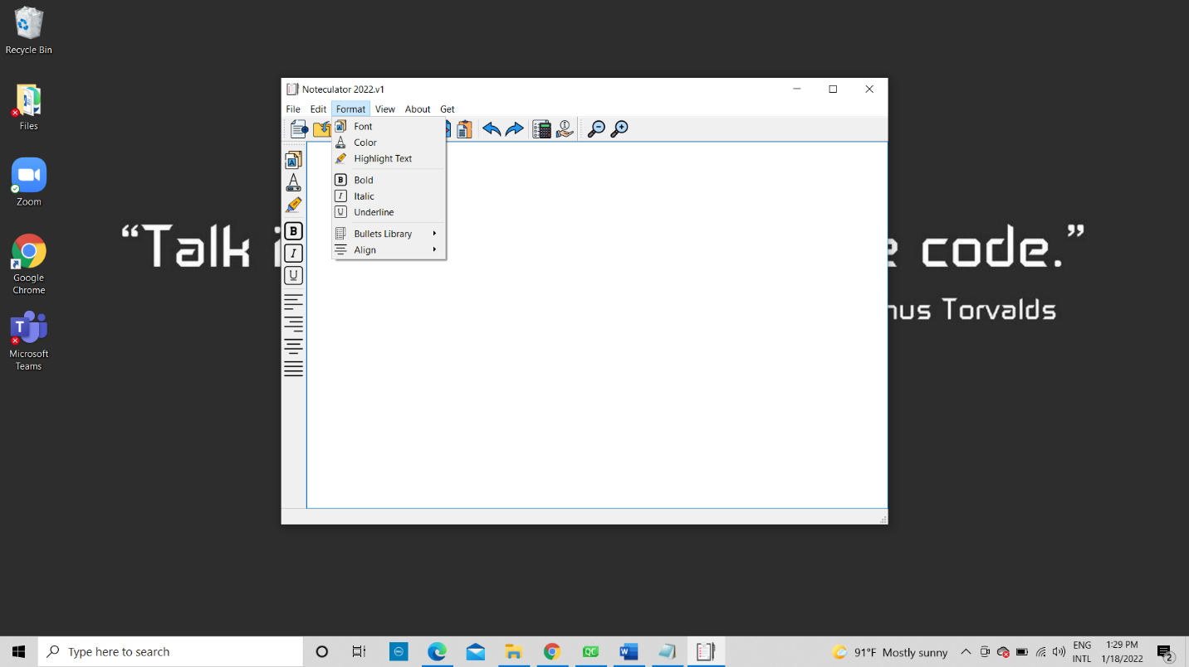

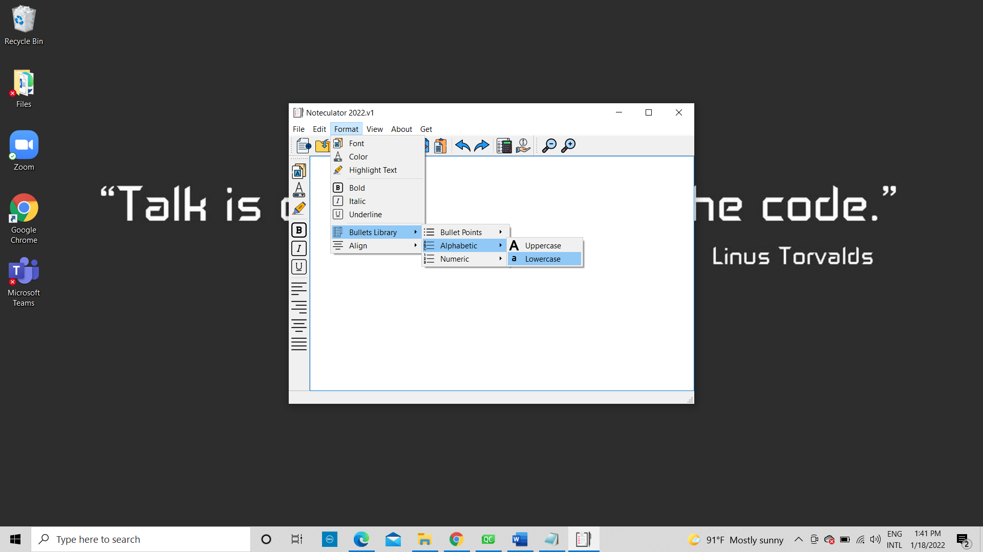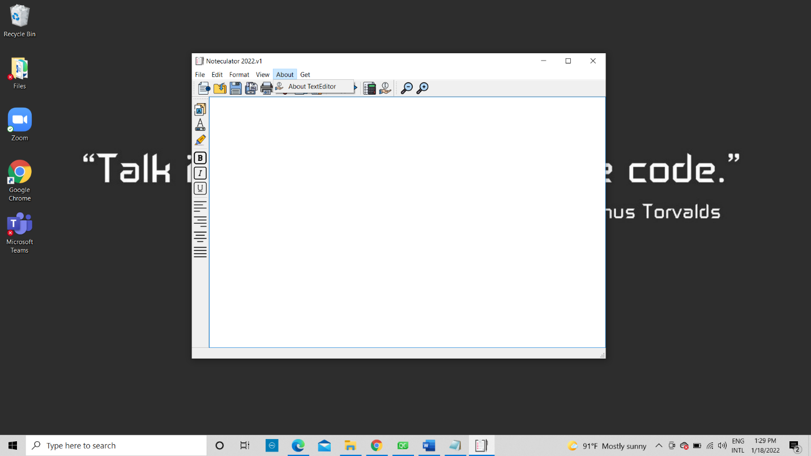

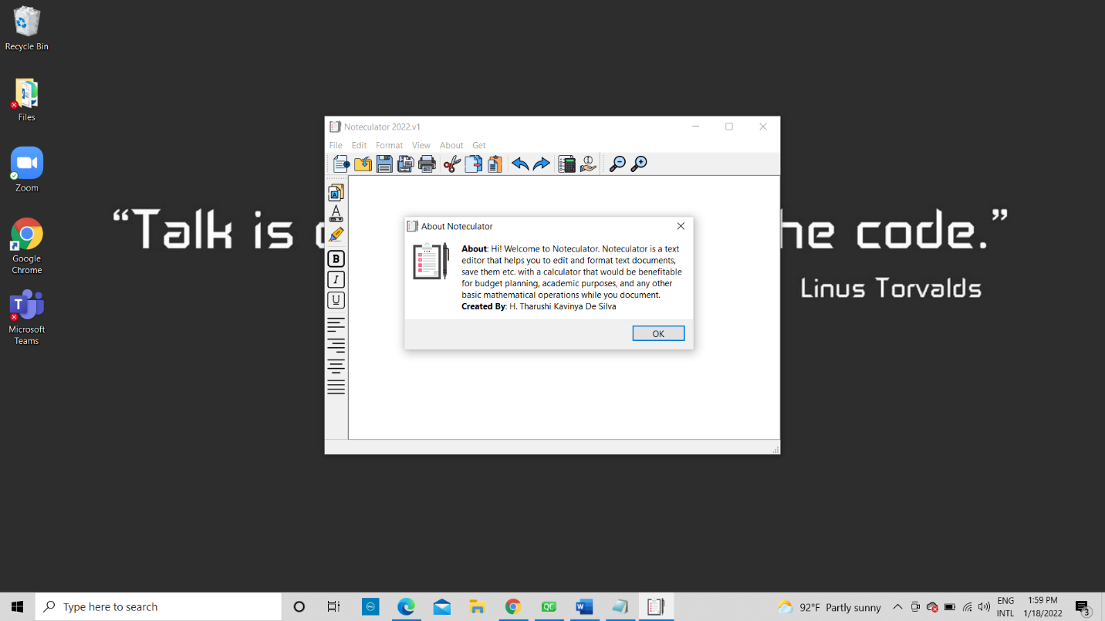

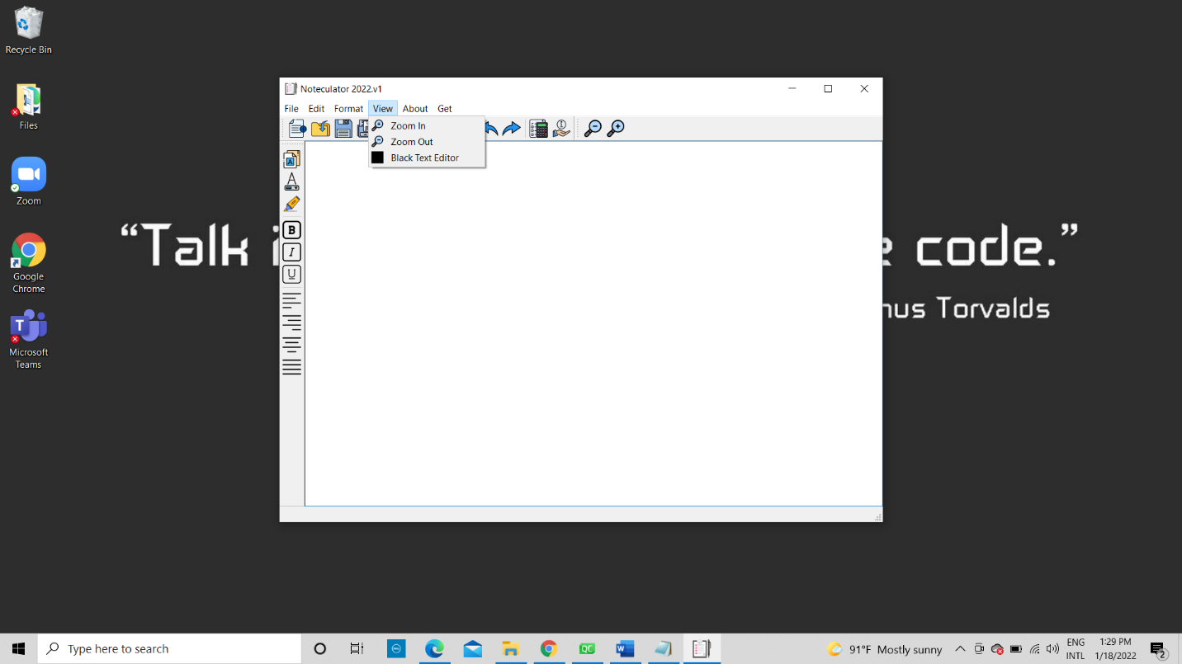

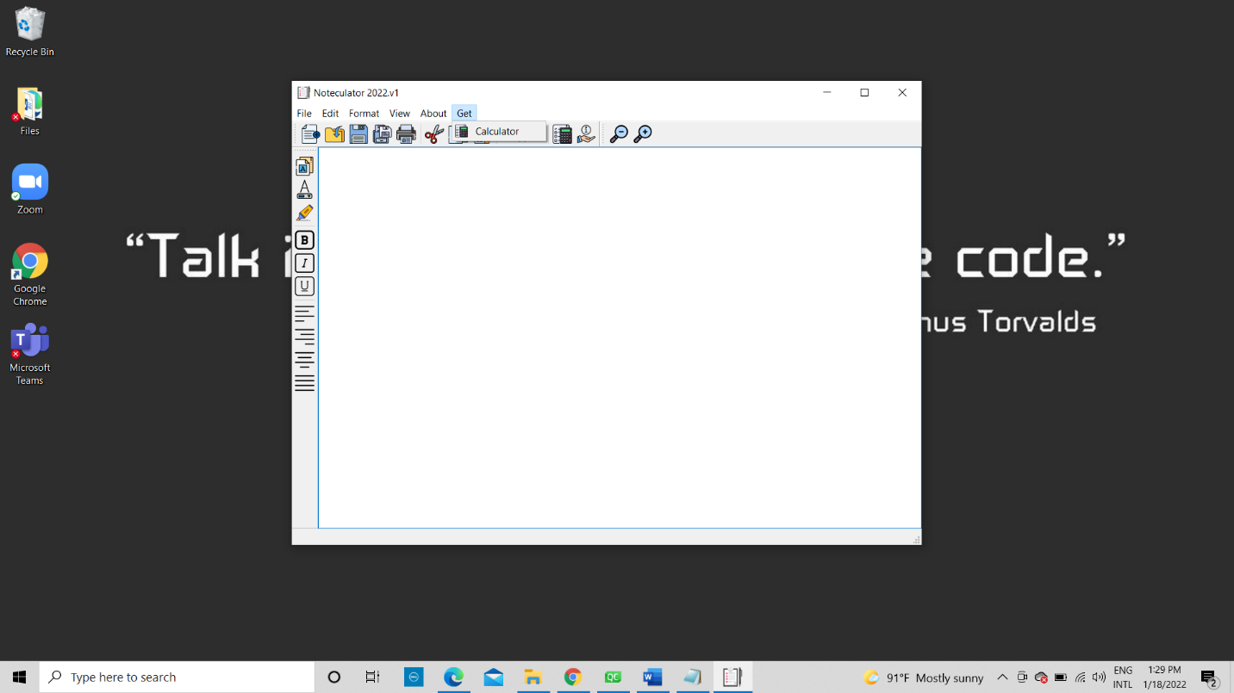Open File

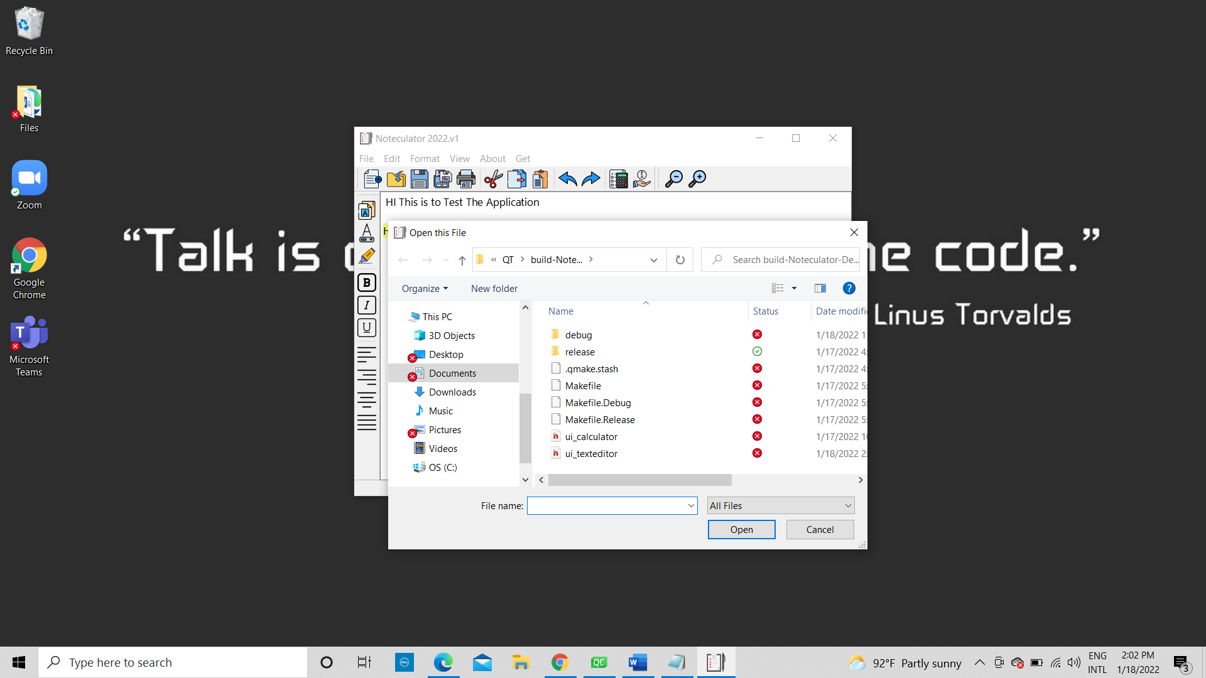

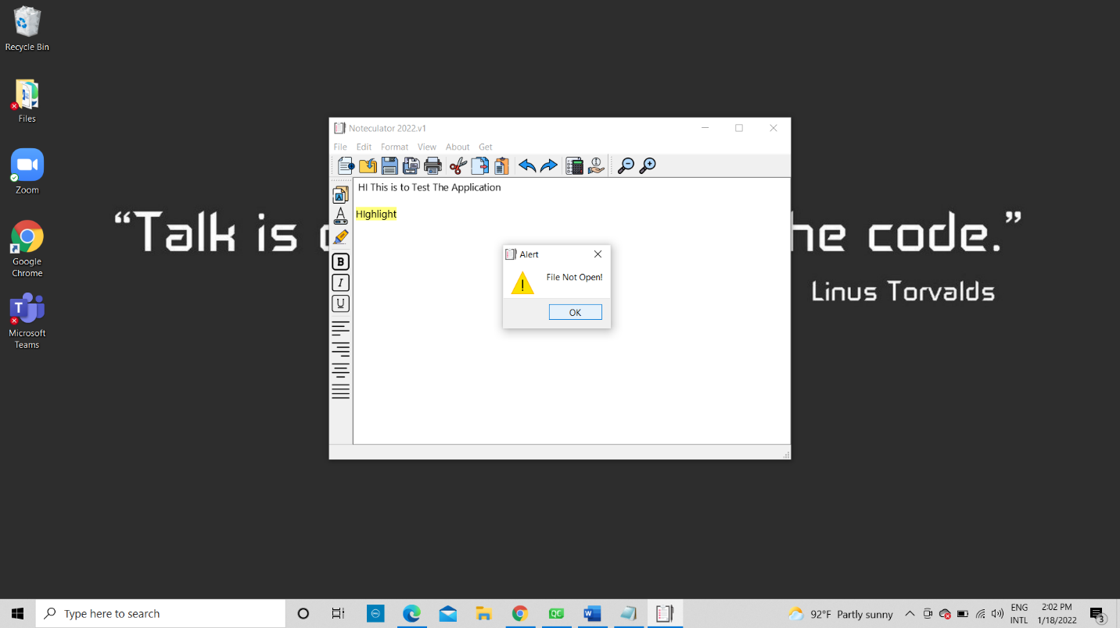

Save File

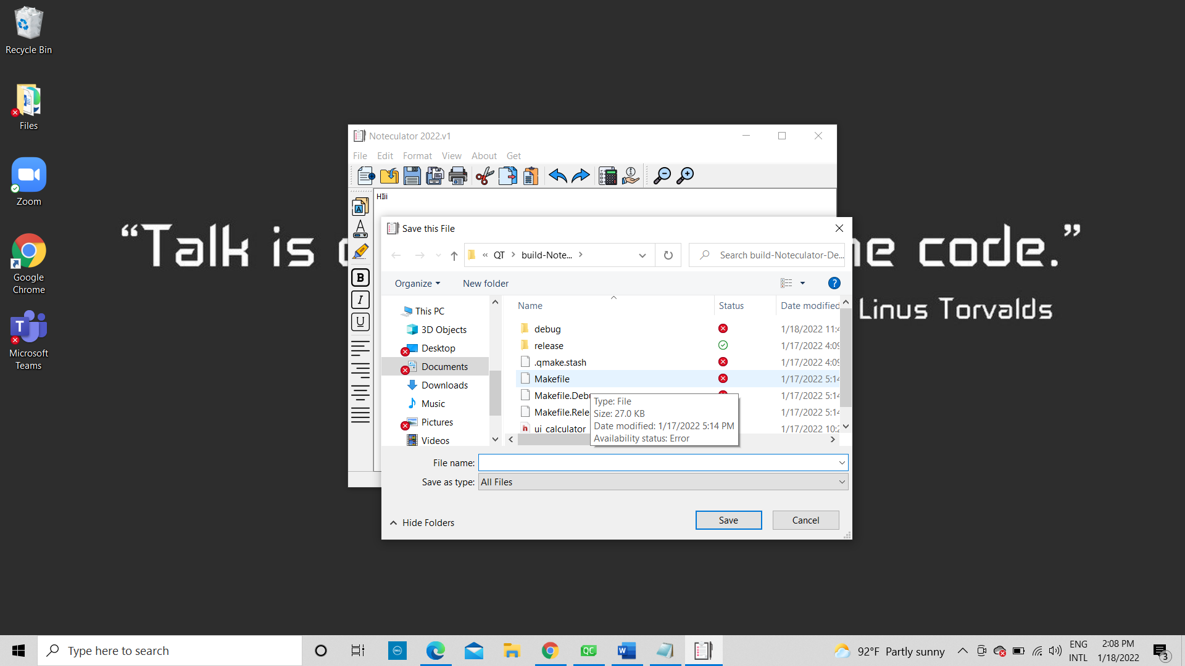

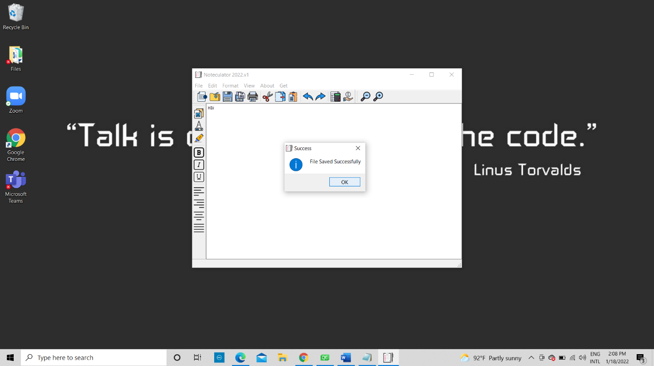

Print

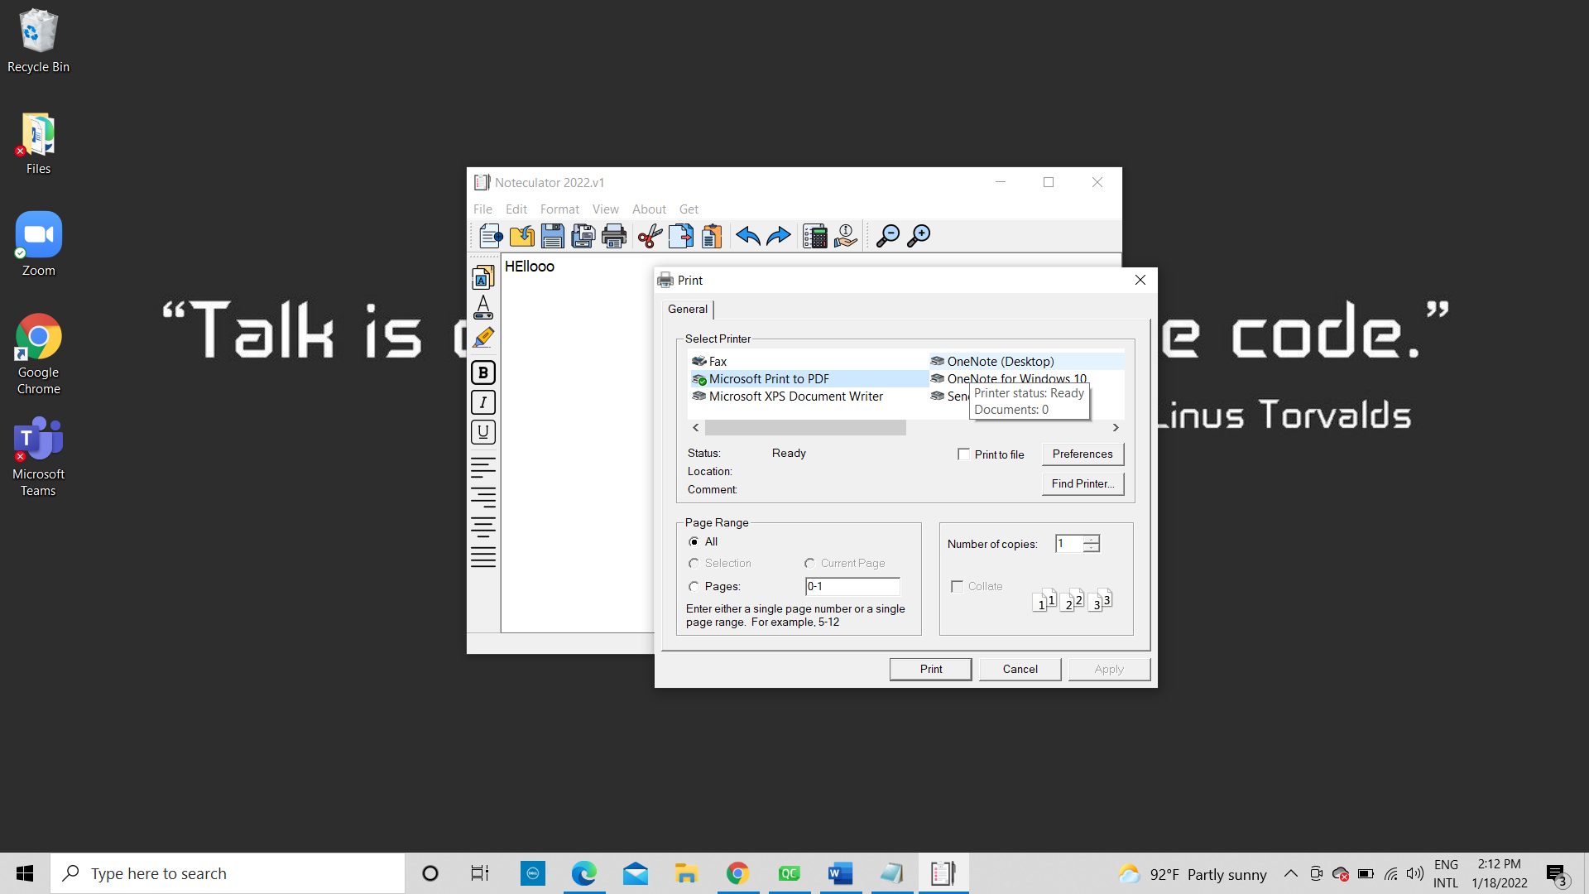

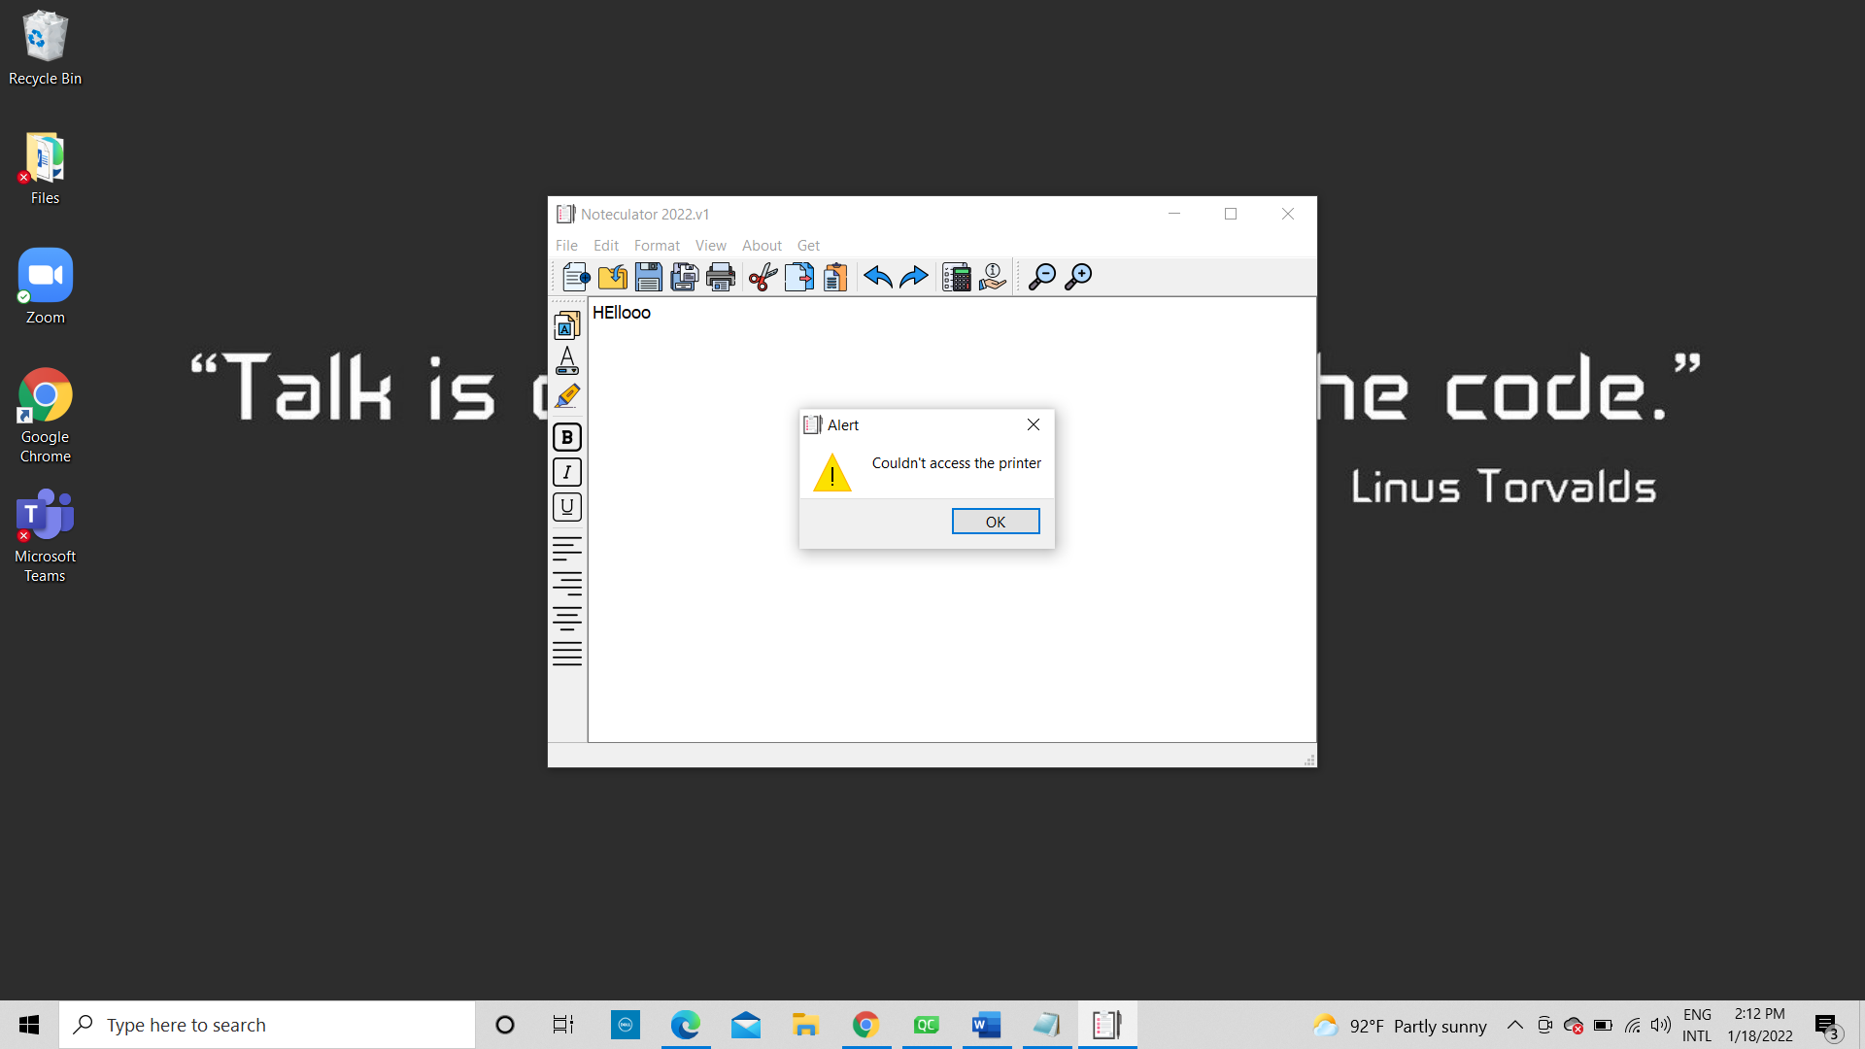

**Formatting**

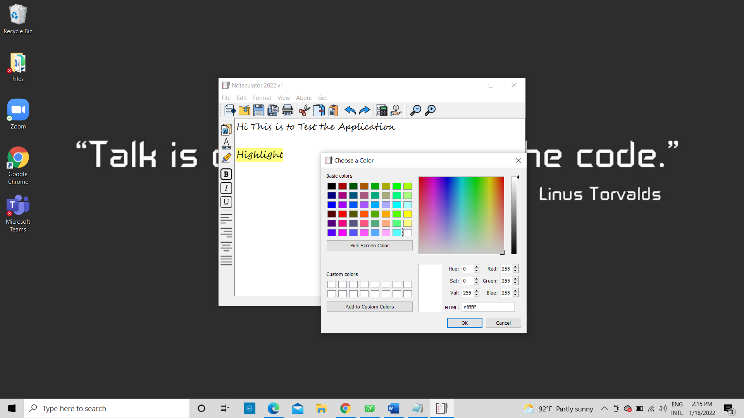

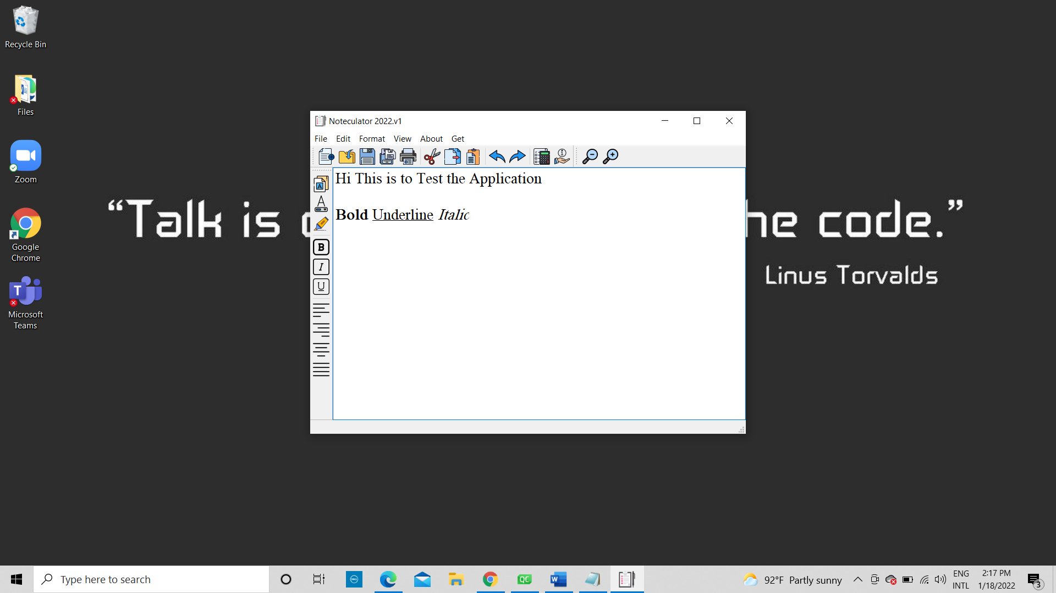

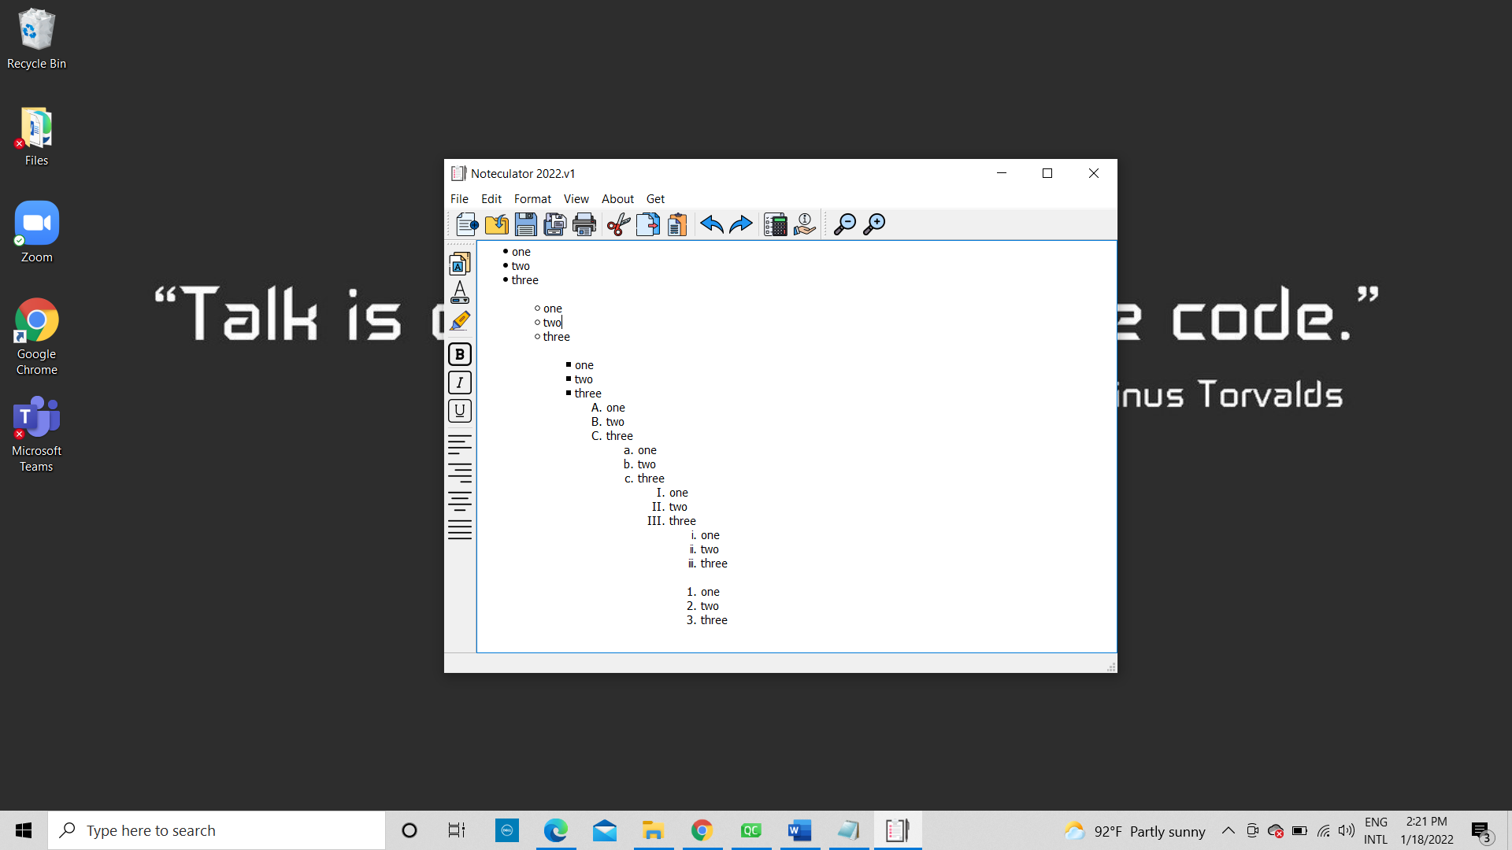

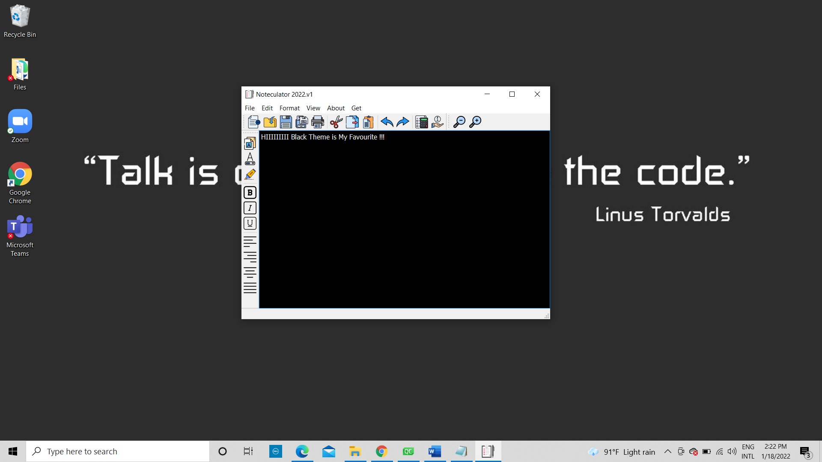

Calculator



Source Code:

Noteculator project file (Noteculator.pro) holds all the information needed by qmake to build the software. Necessary declarations, resource specifications are done there. In here headers, Sources and configurations are assigned to variables.

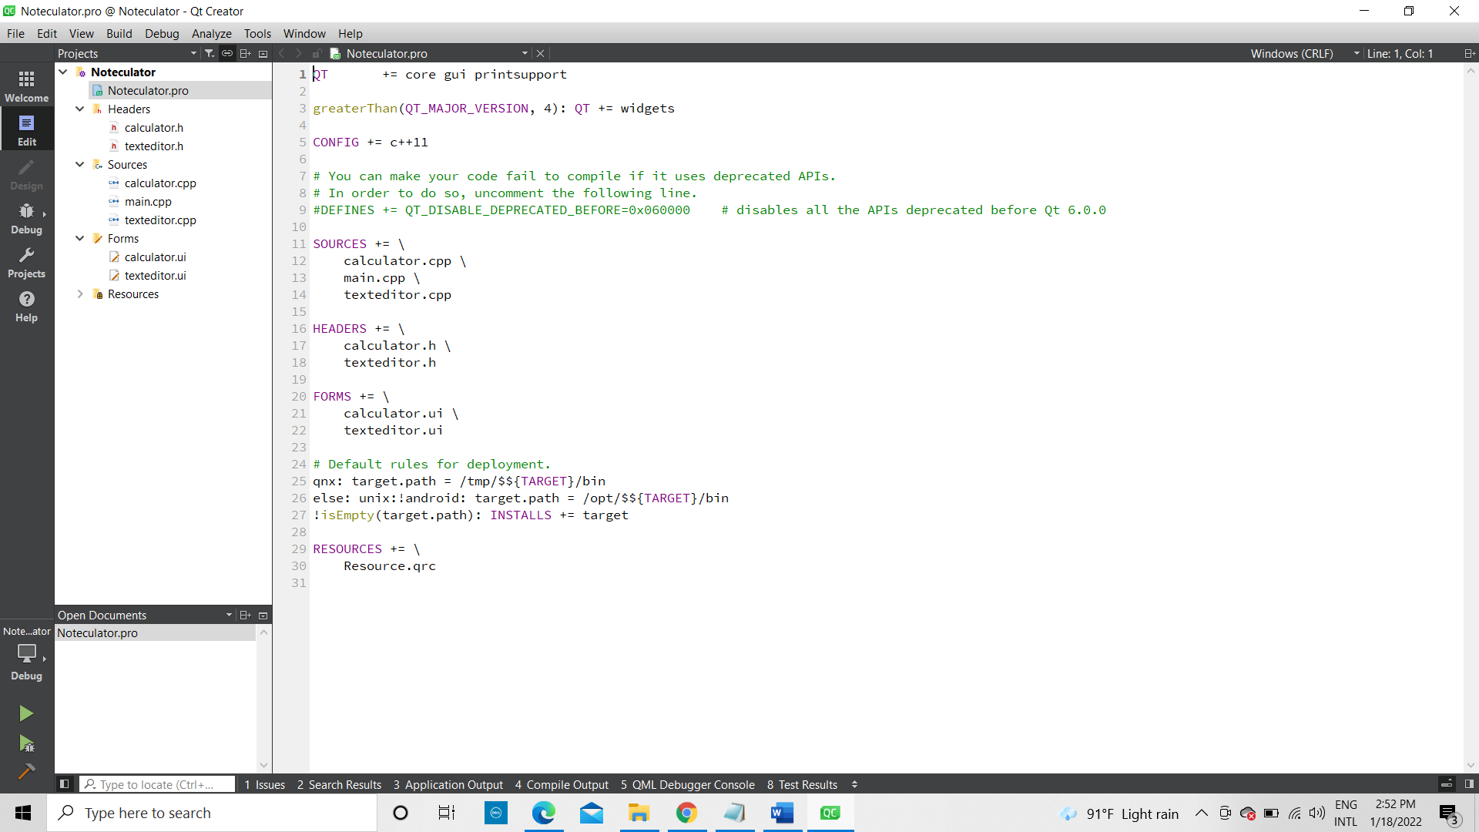

Header Files

Contains interface and declarations for interfaces between Noteculator source files

Class calculator and TextEditor are inherited from the QMainwindow and calculator and texteditor’s ui pointer declaration, slots for the signals are declared here as well

calculator.h

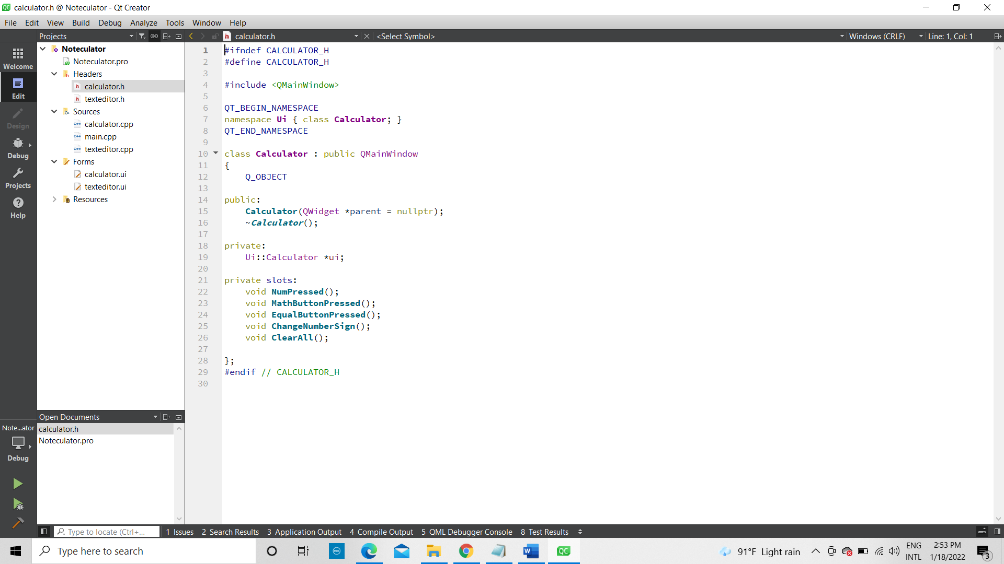

texteditor.h

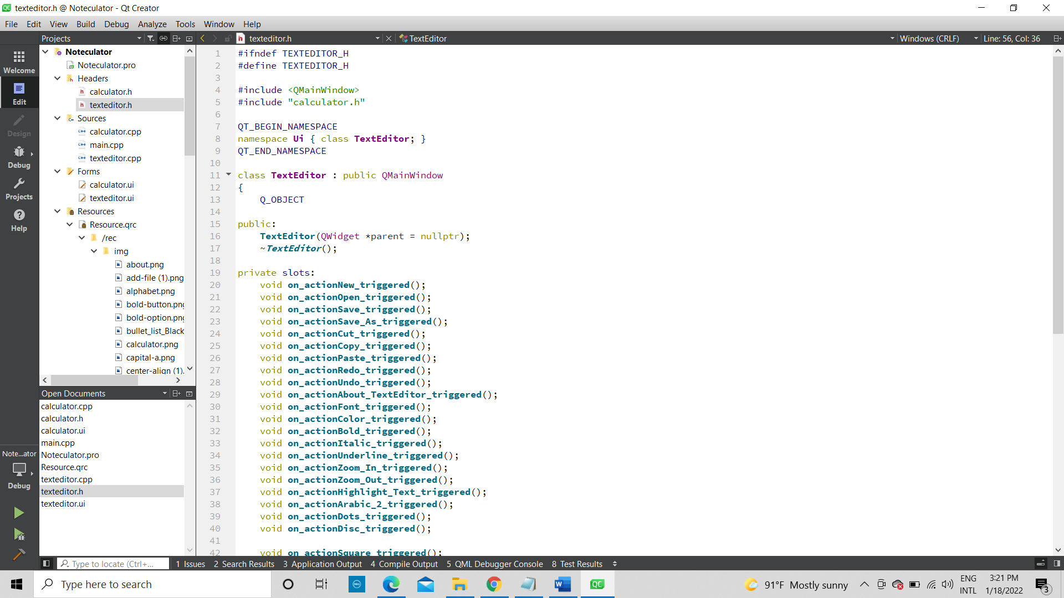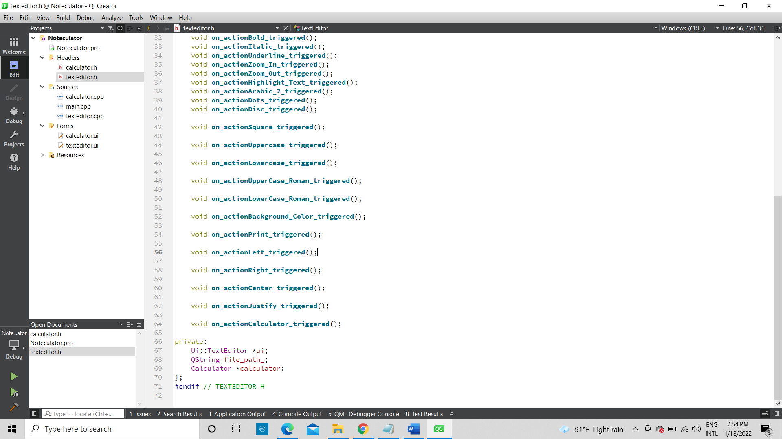

Source Files

main.cpp

This is where the program starts

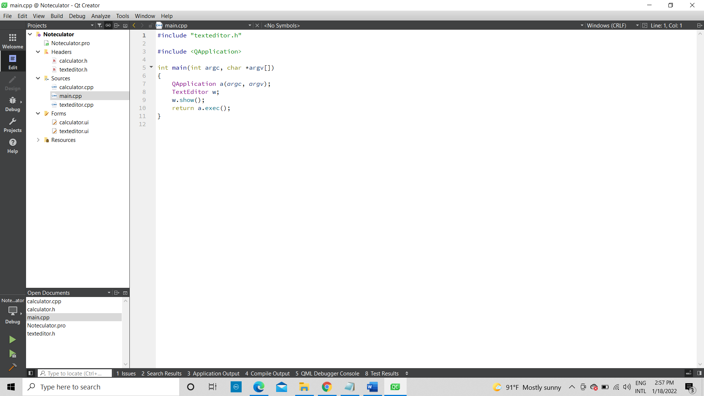

calculator.cpp

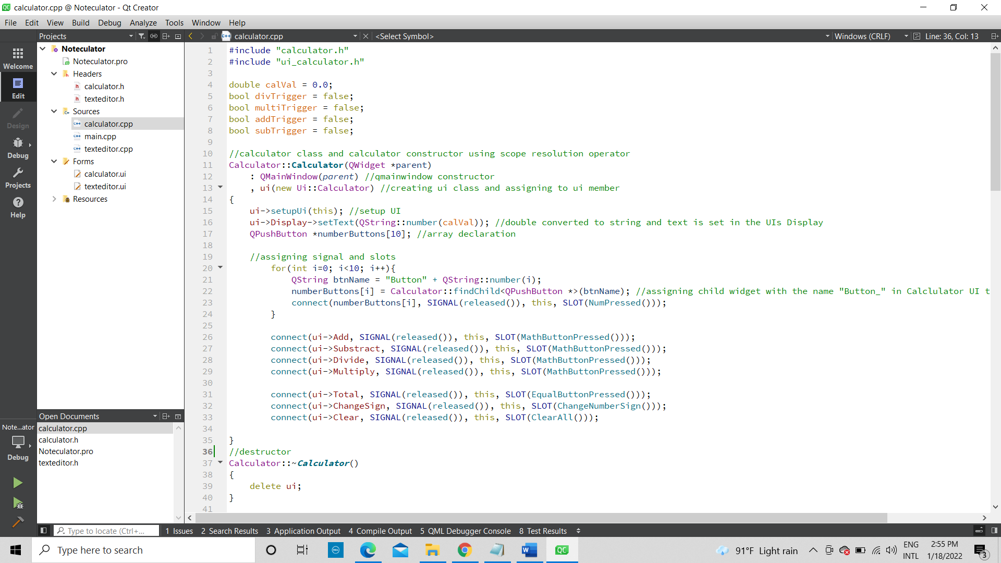

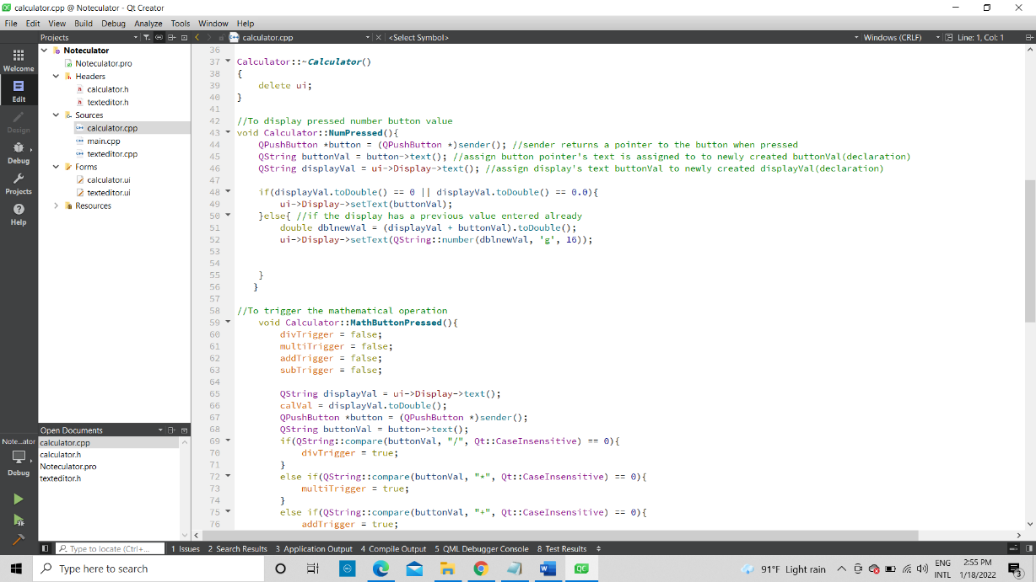

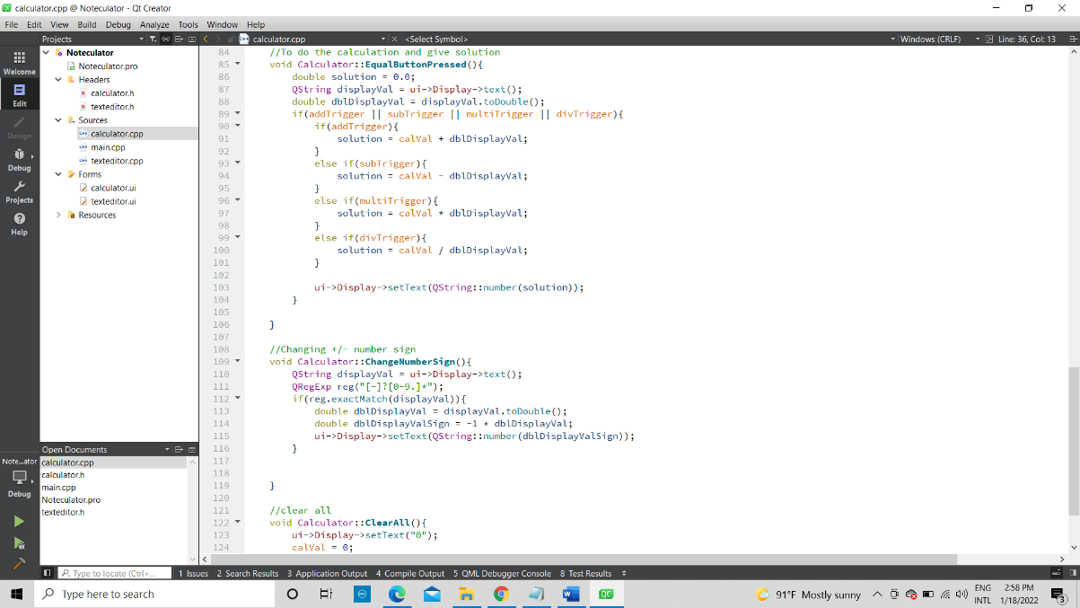texteditor.cpp

The list of QT libraries imported

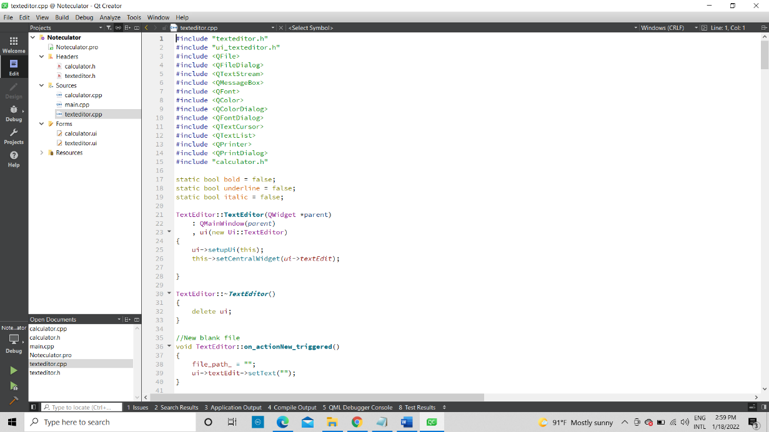

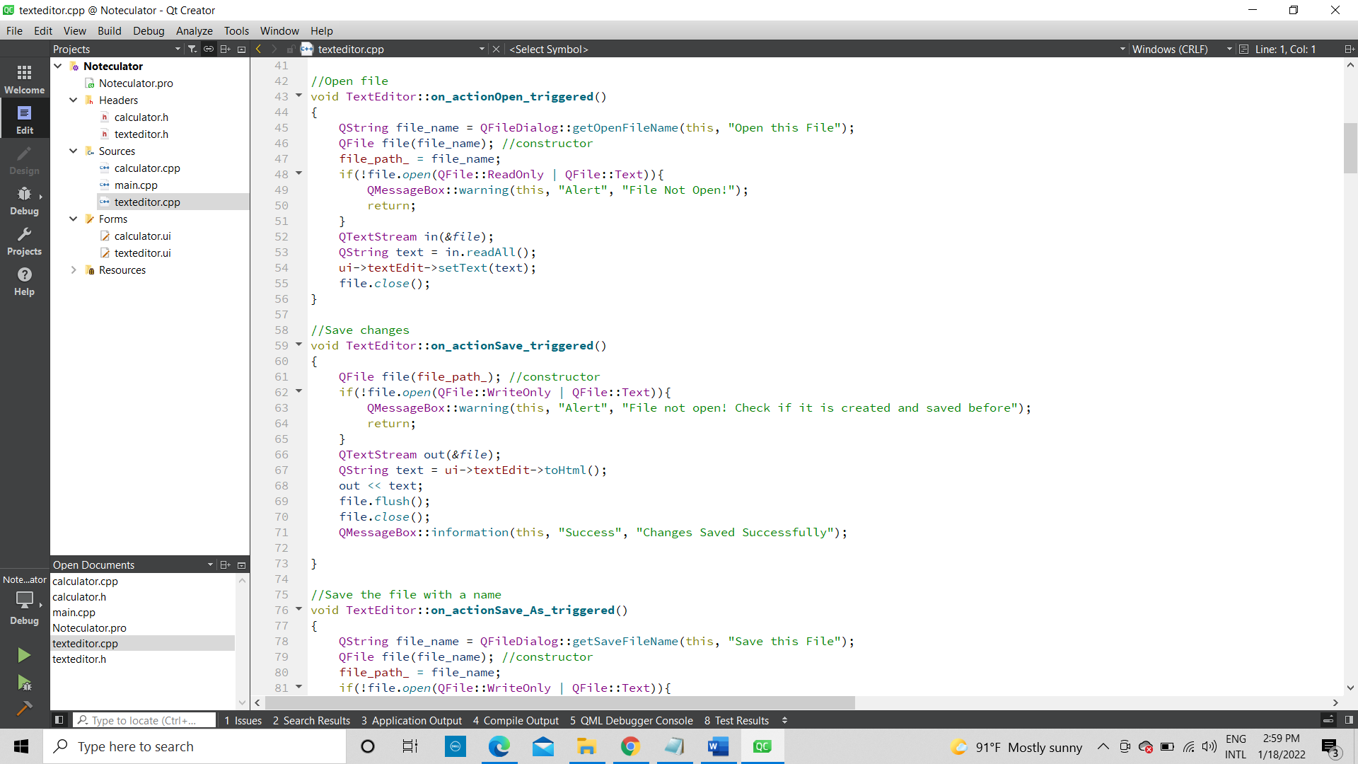

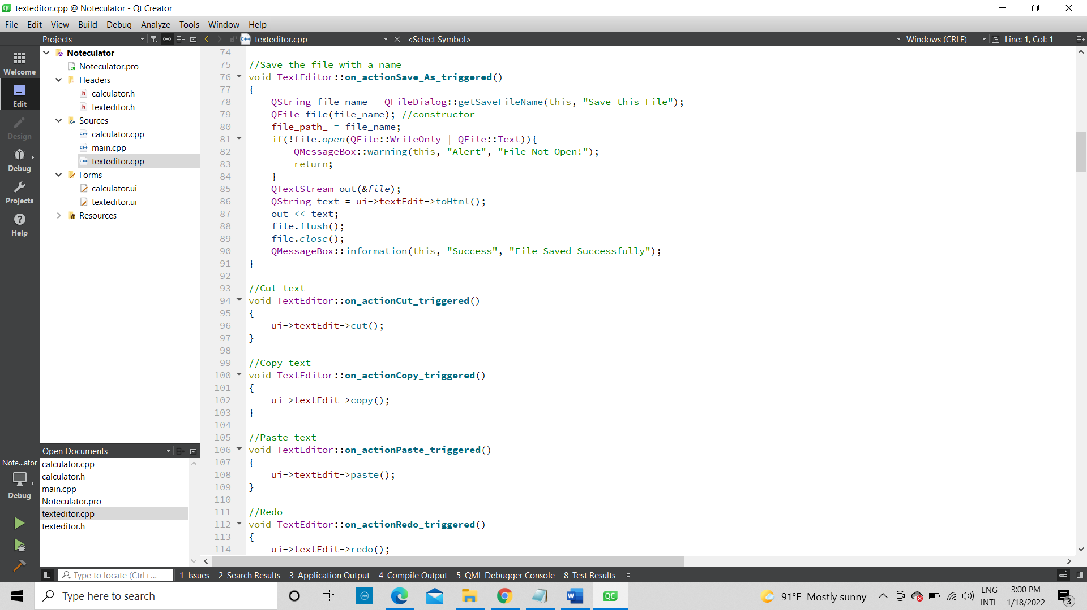

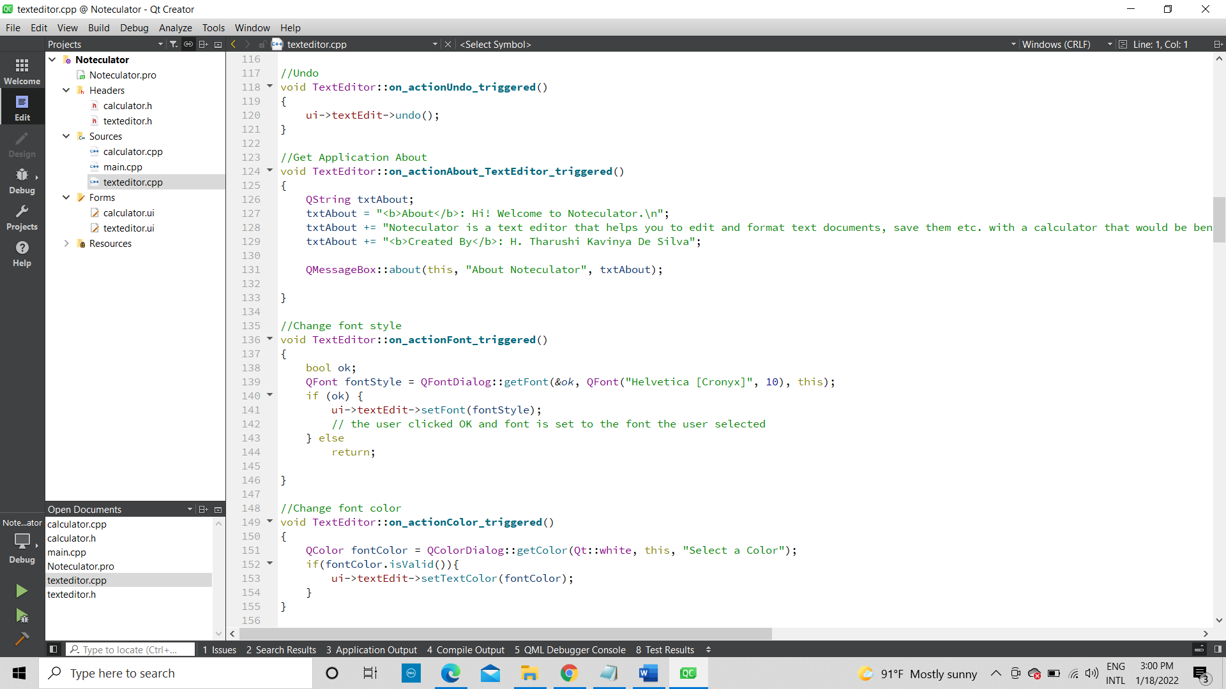

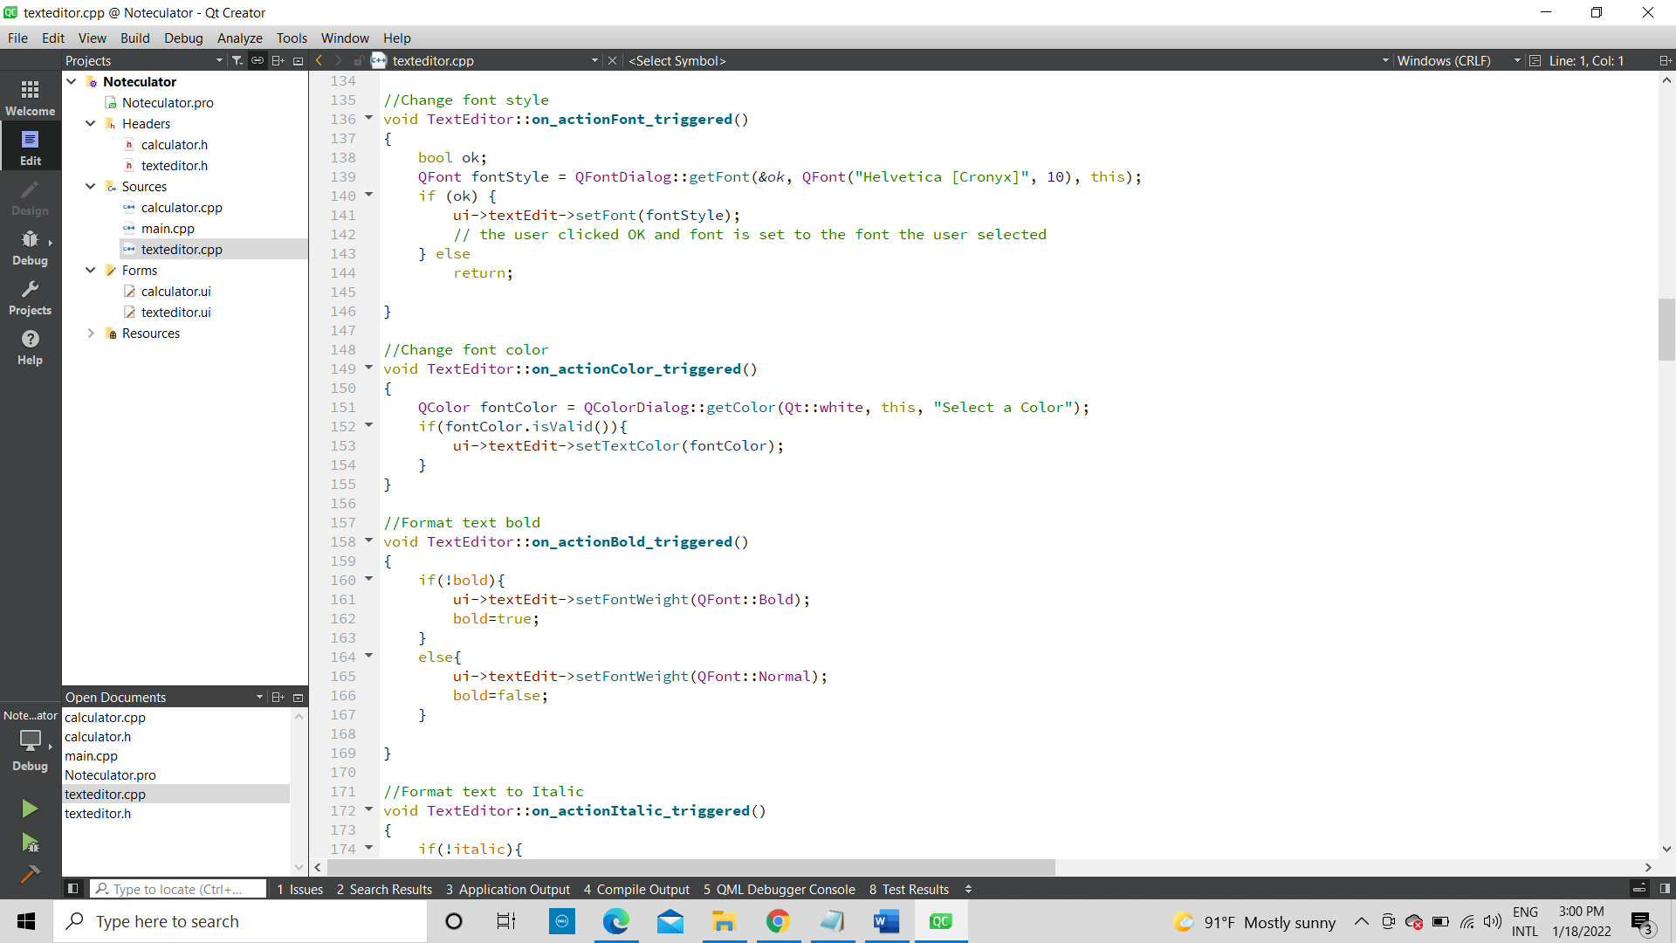

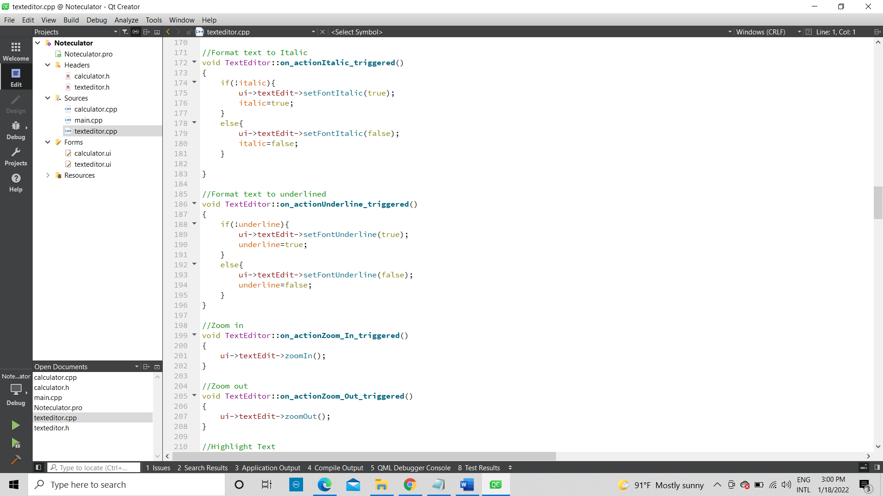

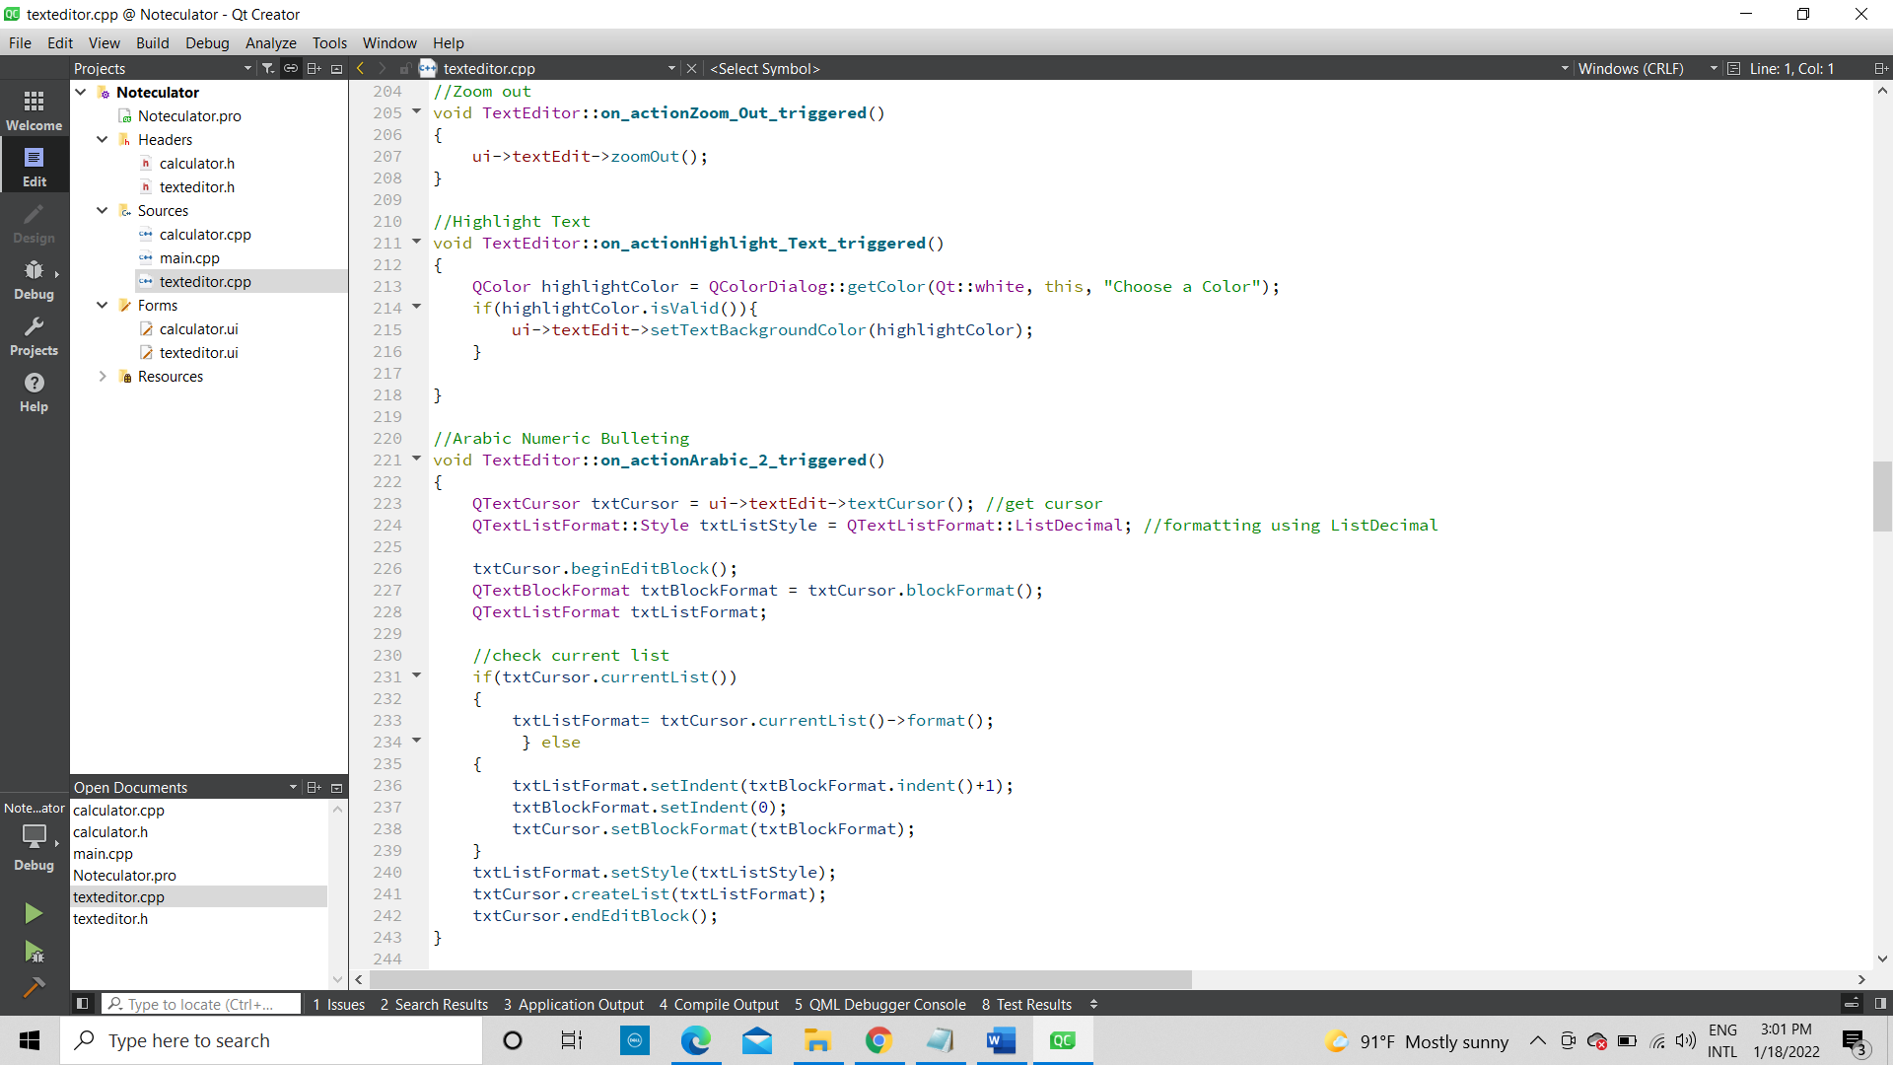

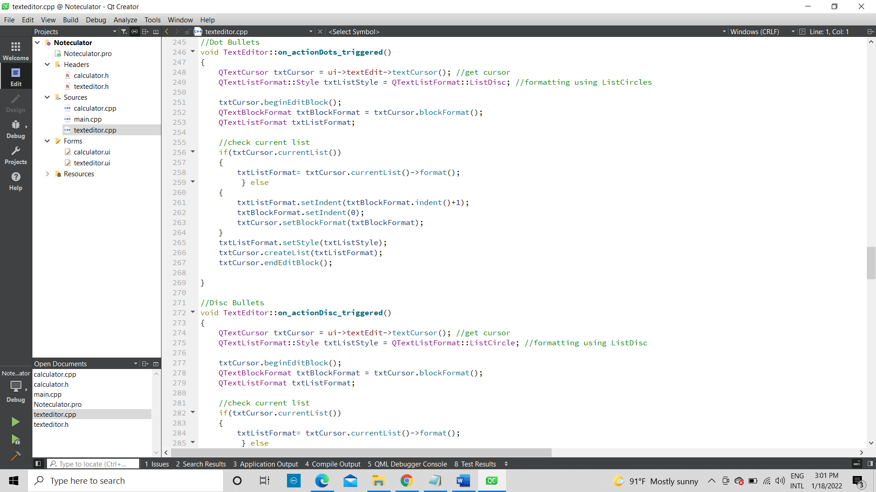

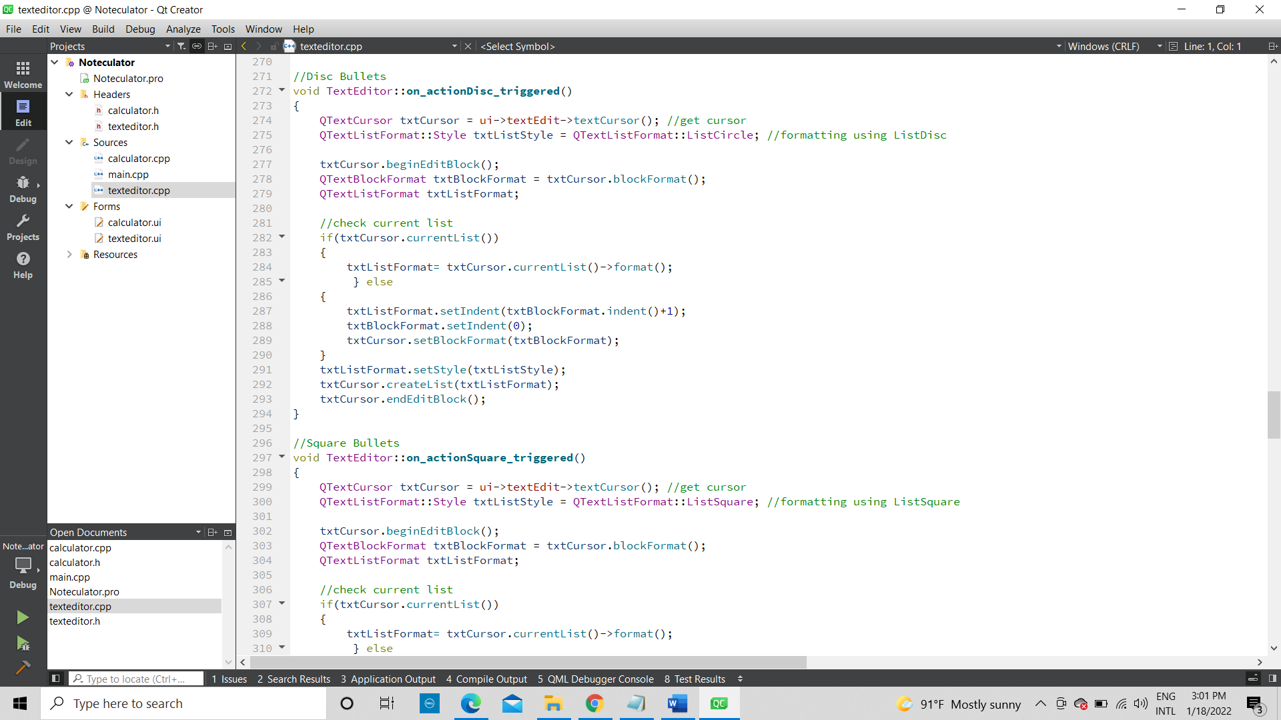

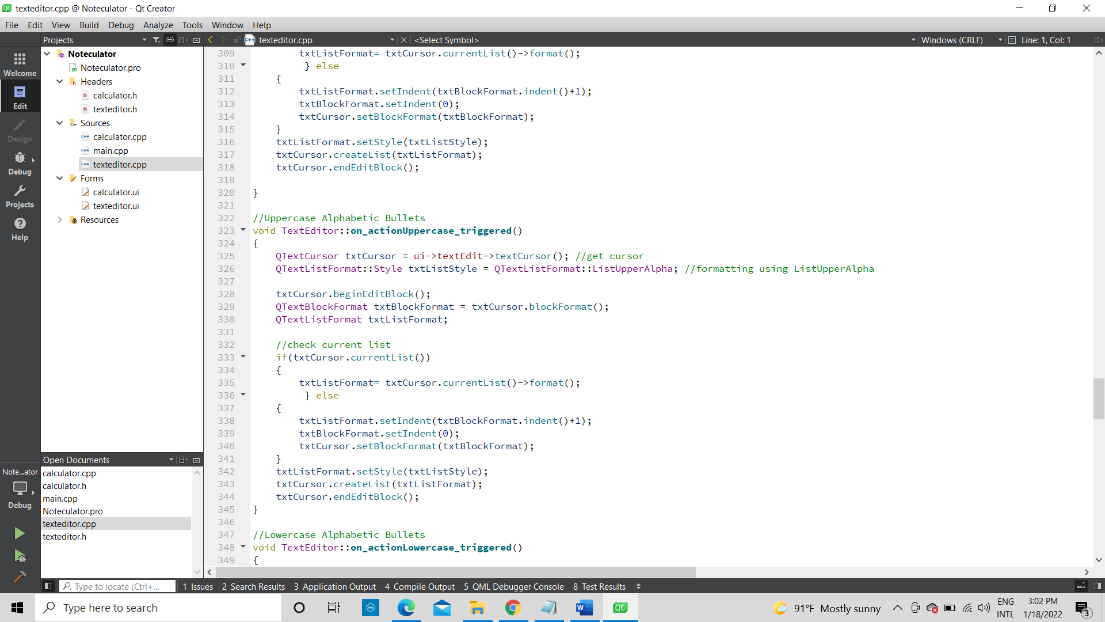

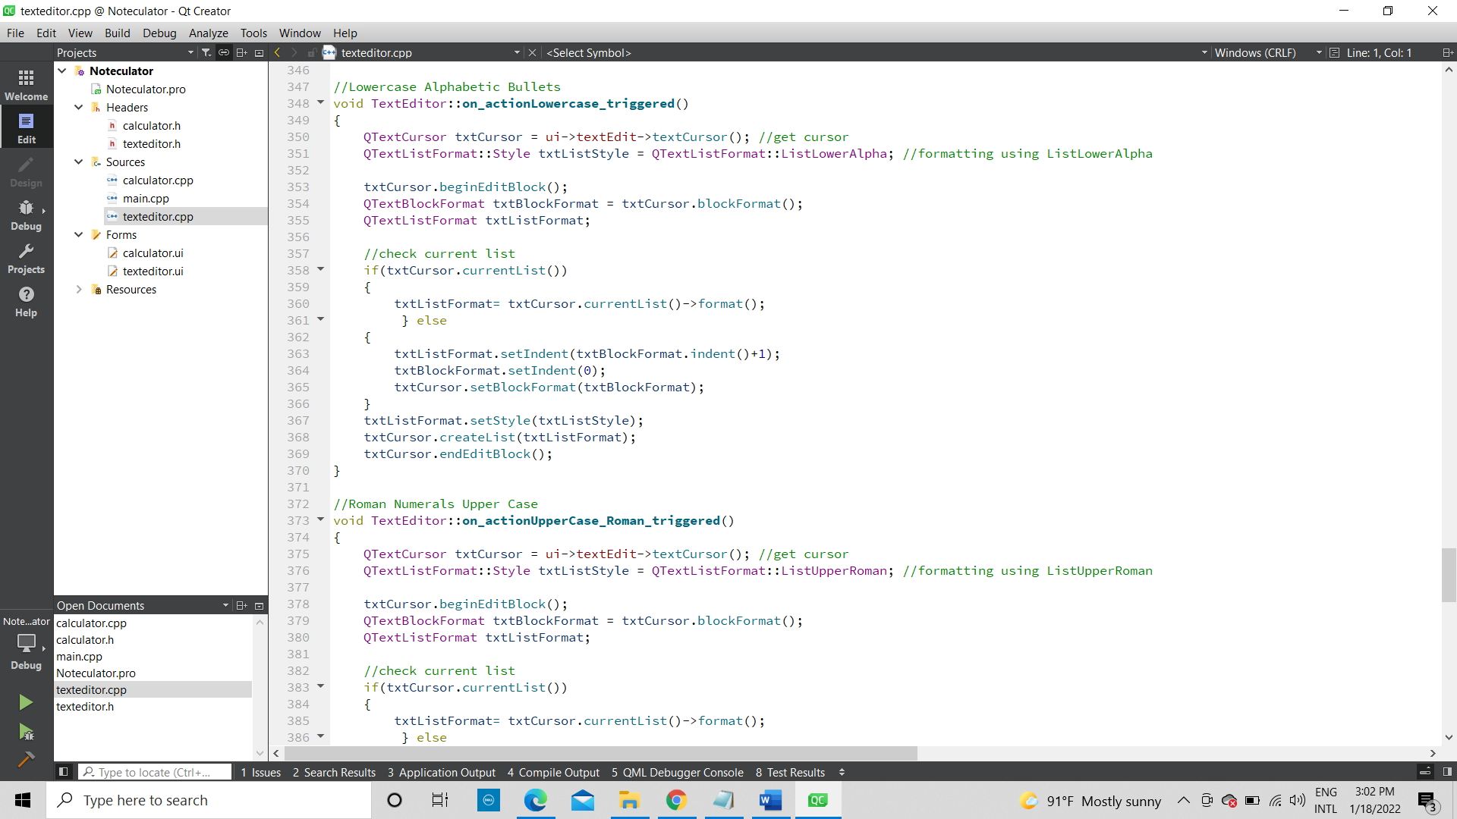

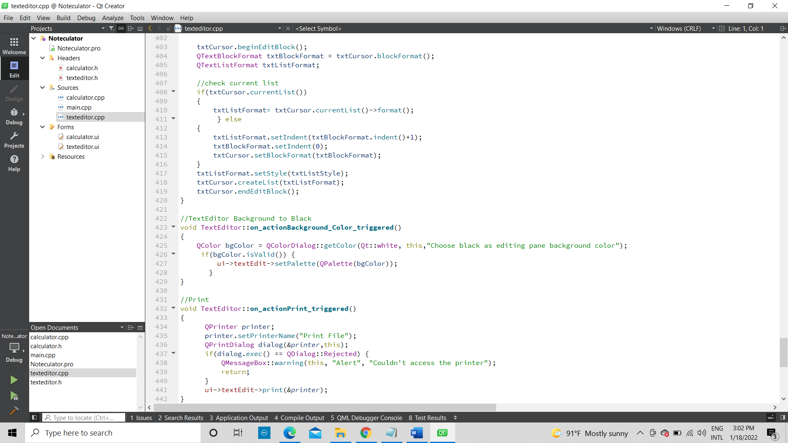

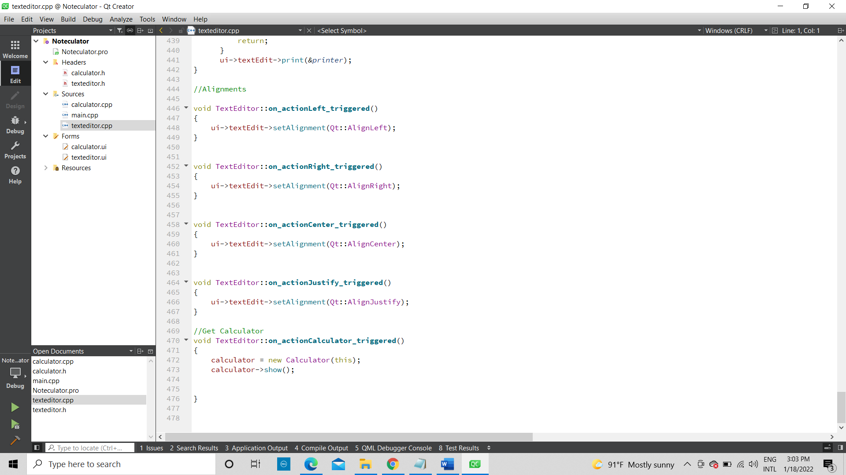

UI Implementation

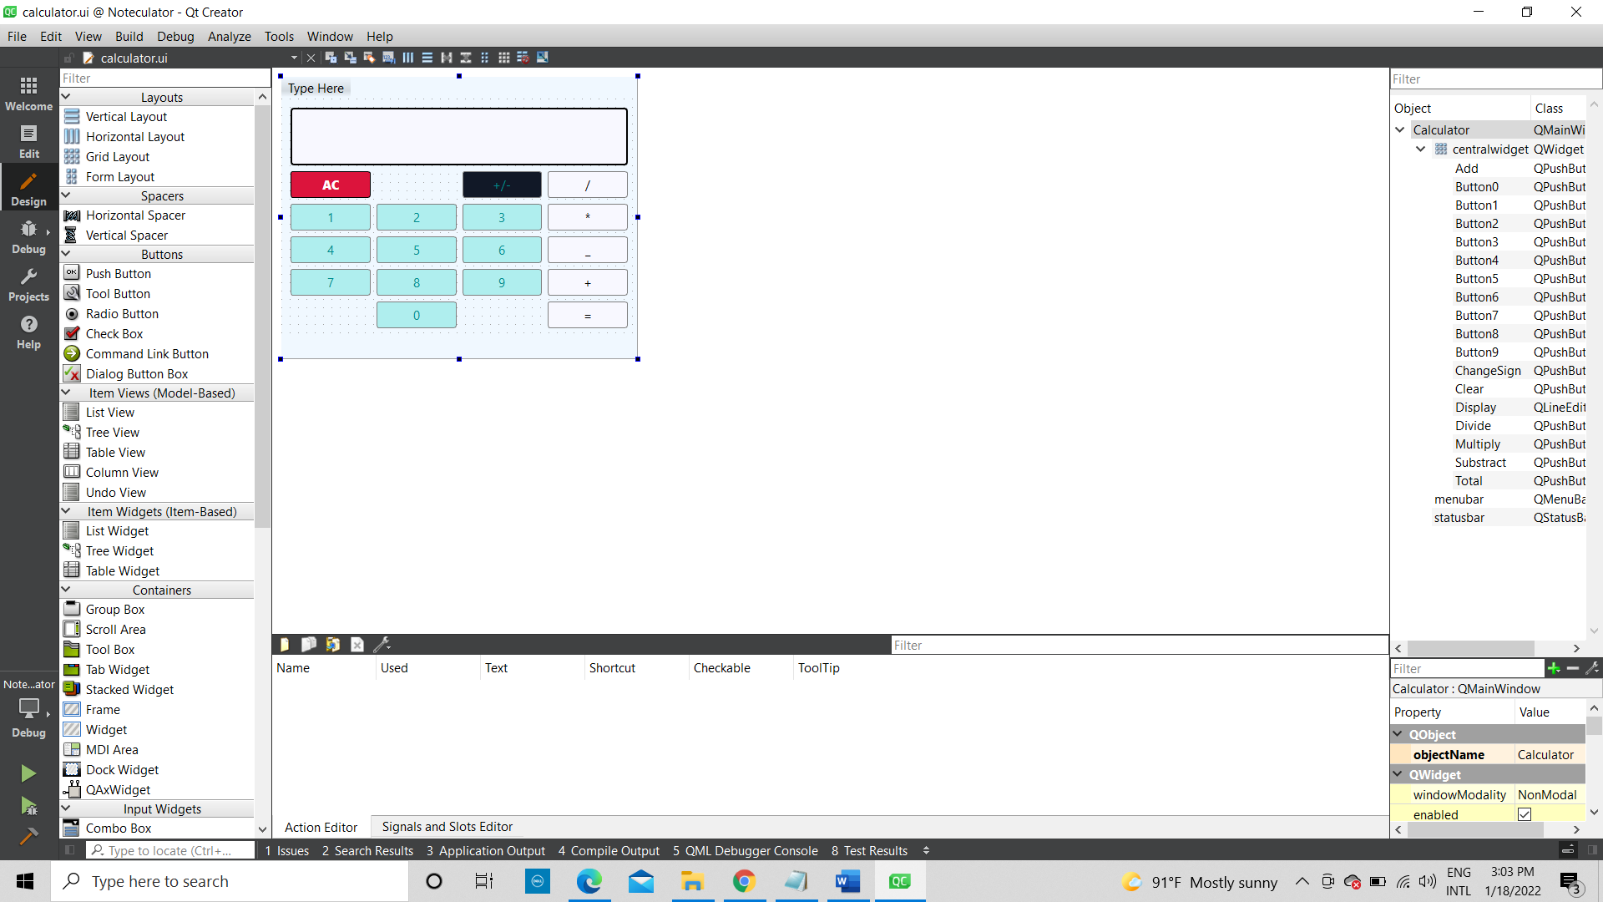

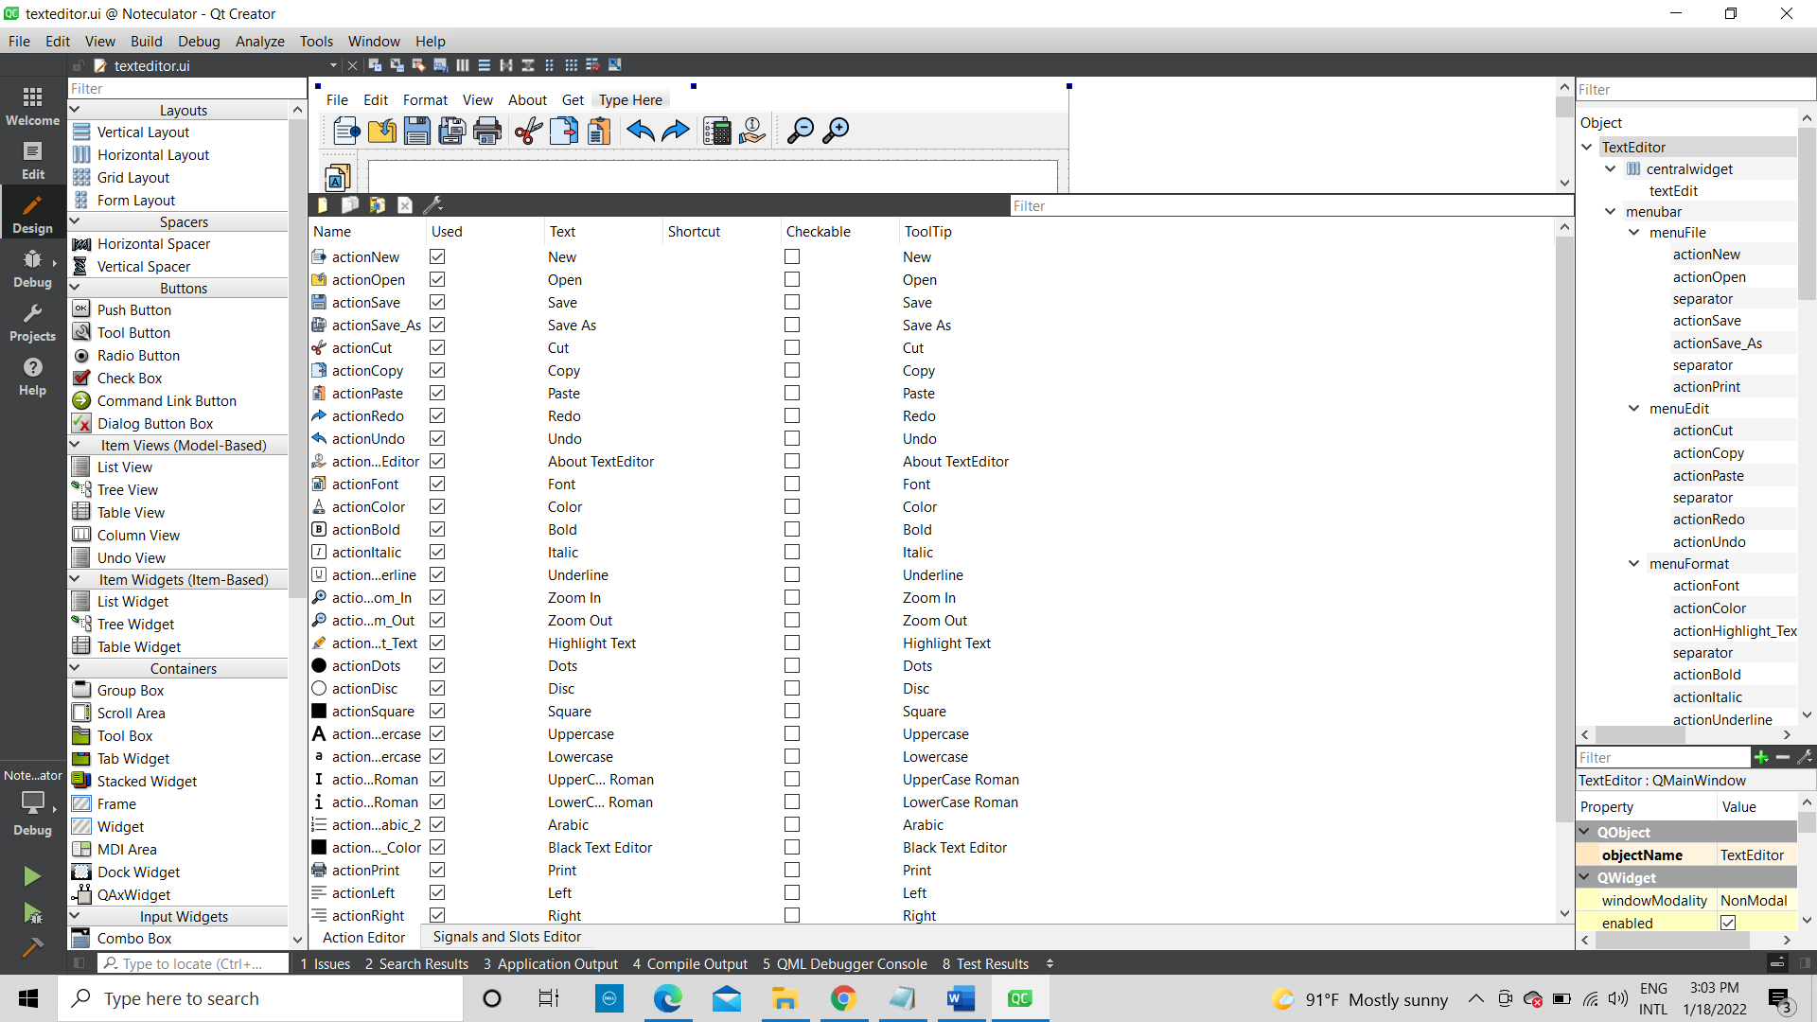QActions, Signasl and Slots

Resource files:

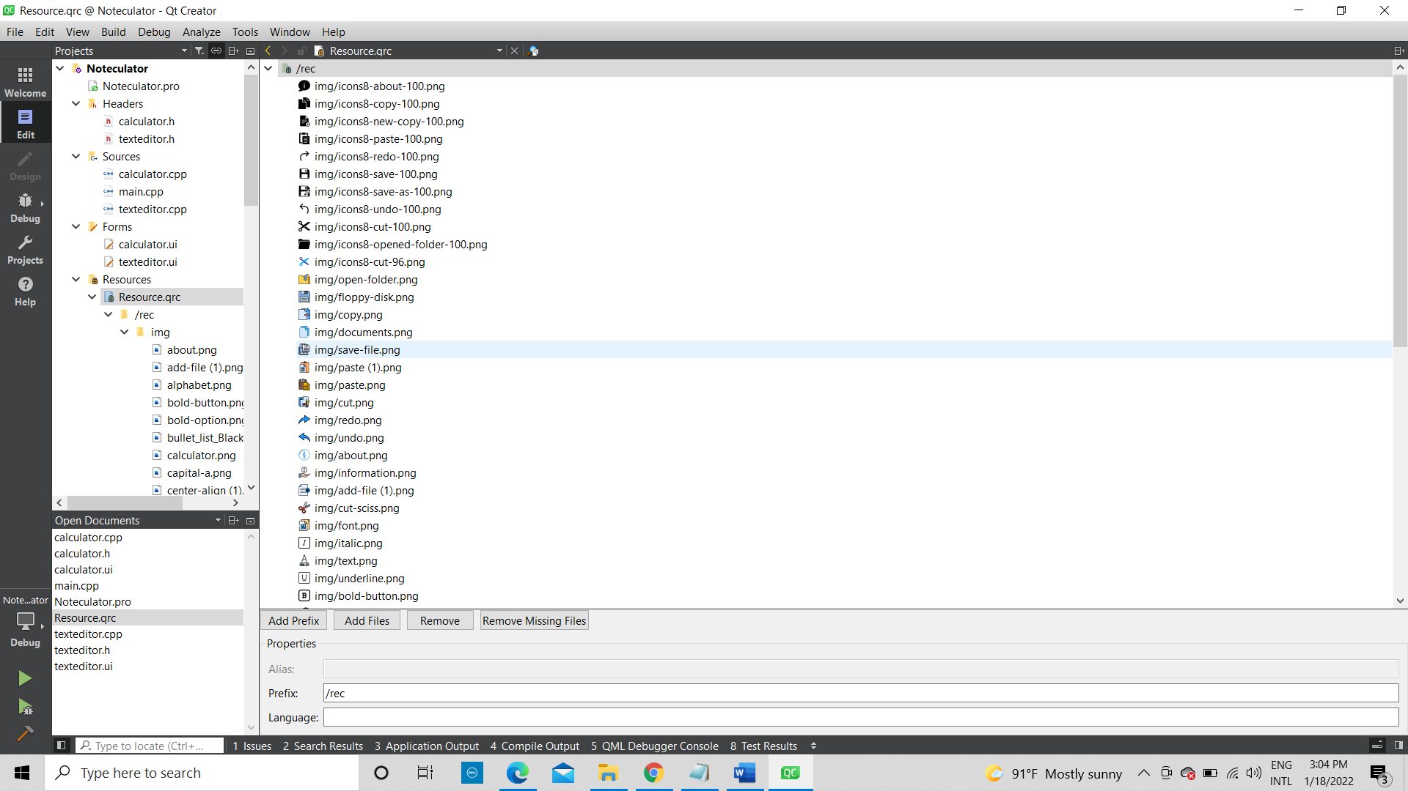References

Lectures and lab materials

QT documentation

<https://doc.qt.io/qt-5/gettingstarted.html>

QT Tutorials:

<https://www.youtube.com/watch?v=EkjaiDsiM-Q&list=PLS1QulWo1RIZiBcTr5urECberTITj7gjA>

<https://www.youtube.com/watch?v=6KtOzh0StTc>

<https://www.youtube.com/channel/UCwRXb5dUK4cvsHbx-rGzSgw>